

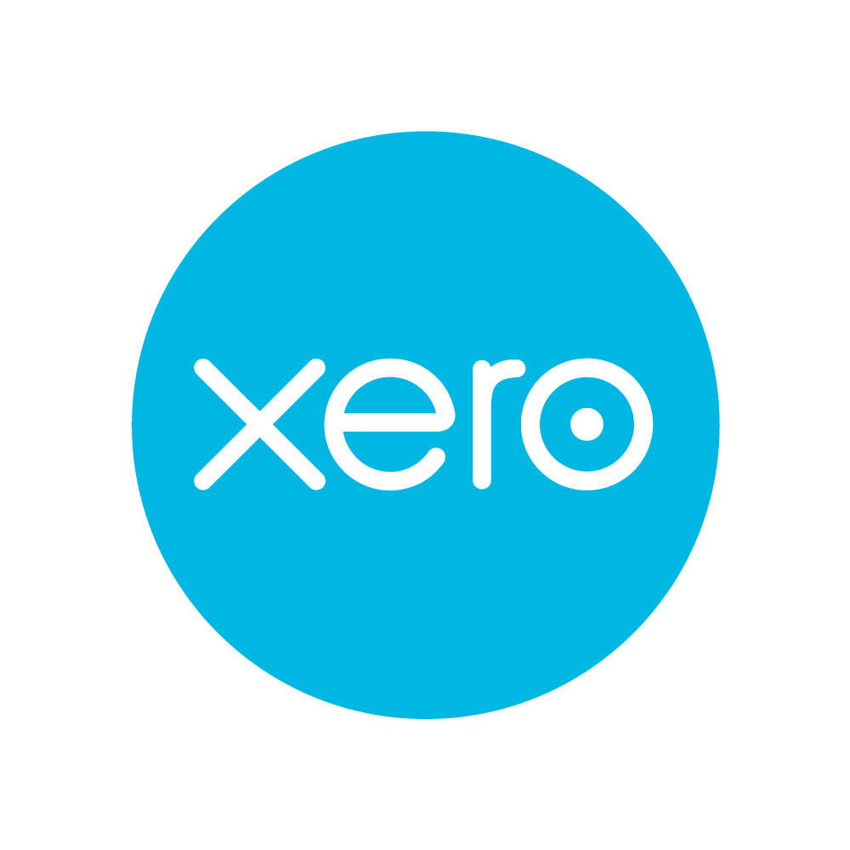
Guide from
[insert your name here]

Tel: [insert telephone number here] Email: [insert email address here] [Insert web address here]

[Insert a line about your business here]

Moving your practice to the cloud

Most of us now understand the concept of software that sits on a remote or office file server, rather than on your hard drive; we see it everywhere in everyday applications as diverse as Gmail, Facebook or Flickr.

But do we understand the benefits offered to accounting by a cloud-based solution? Has the accountancy profession really grasped the potential of online, instant access to clients’ financial information? And are accountants making the most of this new ability to move beyond basic bookkeeping and compliance services into higher value advisory services?

Why should I move to the cloud?

Moving your practice tools to the cloud is no small feat; we’re talking about shifting all your practice management, tax, accounts production and bookkeeping systems online. Xero highlights the following recurring themes among accountants it has worked with:

- Many are interested in moving their practice to the cloud but just don’t know how to take their first steps.
- Some simply aren’t ready and want to be convinced that the cloud is for them.

Overall, everyone wants honest reasons, with clear steps on what to expect and what to do – not just a sales pitch. With that in mind, we’ve produced a guide that takes you on the journey from Cloud Sceptic to Cloud Expert.

Sometimes we’re asked: ‘Why should I move to the cloud?’ There are many benefits to a software-driven, cloud-based accounting solution. But one of the main reasons is the ability that it gives you to work more collaboratively with your clients. By offering higher value advisory services that go beyond the basic tax and compliance package, you can increase your revenues and become a trusted business adviser to your clients.

Making up the revenue gap

Another principal benefit of the cloud-based approach is that you’ll get your jobs done more quickly. Faster processes, driven by better data analysis, mean that you’ll spend less time on the basics.

But this does raise a potential issue: if you complete a job more quickly, you’ll be charging fewer hours. Initially, you might worry that this will leave a gap in your revenues. So, how do you resolve the problem of a revenue gap? Does eliminating the donkey work result in less billable time and, if so, how does working in the cloud affect that?

We’ve already described how a cloud-based approach can help you deliver additional services for your clients. By basing your fees around the value you add – rather than the hours you spend on the job – you can fill that revenue gap. You can move beyond the basic level of service and add services such as management accounting, data analysis and business consulting – all of which help your client to achieve their financial and business aims.

Alternatively, if the idea of building up extra income by offering higher value advisory services doesn’t float your boat, feel free to absorb the extra efficiencies and time savings that the cloud brings and enjoy life more.

Being able to collaborate with your clients on the single ledger in Xero is another important feature that improves the way you can work with small businesses. You can spend time talking to your small-business clients about what their financial numbers really mean and what decisions can be made to move them forward; compare this with just trying to get the numbers right and finding and fixing those hard-to-find data-entry errors. This is how you can make up that revenue gap and provide value-add services that make your clients even more satisfied. This improves your working relationship while making your practice more profitable.

Step 1 – start using cloud solutions

If you’re going to recommend cloud-based accounting software to your clients, you need to understand them yourself. You’ve got be a true advocate for this way of working, and the best way to do that is to adopt them for your own practice’s accounts.

It’s easier to understand data from your own practice (rather than a ‘sample company file’), so you can focus on what the differences are between your new cloud-based solution versus your existing desktop or hosted solution. By doing this, you’ll learn using numbers that are relevant to you, rather than trying to make sense of hypothetical data.

At this point it’s important to learn the practical challenges that come from migrating from your old way to your new way. Understand how the products are different from what you currently use, from the wording to the workflows. Keep asking yourself:

- What’s different?
- What’s new?
- Can I do this?
- How do I do this?
- What does that do?
- Why is this done this way?

Beyond this, think about how you’ll take the next step with your practice while using the product. For instance:

- Which of your clients would work best in the cloud? Which would not?
- How you can improve your client relationships using the technology (eg proactive client management, collaboration tools and increasing client activity with their financials)?

Note down the various surprises you have along the journey. Get answers by checking with your professional networks or by asking the vendors for support. Again, this is a risk-free way to learn, so make sure that you get the most from it. By doing this, you’ll gain enough confidence in the cloud to really become an advocate.

Step 2 – identify the right clients to move first

It’s one thing to learn by using your own data as we talked about in step 1, but another to experience supporting a small-business client with their own data.

There can be various situations that provide the impetus for the switch. For example, one easy and profitable opportunity is clients who currently do their accounts using Excel spreadsheets. You can import their existing data using Xero’s conversion tools and turn processes that used to take days into something that takes hours.

Cloud solutions are based on subscriptions and are typically at a low, monthly rate. You can provide a consistent monthly billing, and break up the costs over the coming months and year, rather than take a one-time hit. This also allows you to try out value-based pricing. Value pricing, in the most simple terms, means charging your client a fee for the value they feel that you’ve added and doing this prior to the work being delivered.

Things to consider

One important thing to consider is the timing. When’s the best time to move over to the cloud? Most practices prefer the end of the fiscal year, to start the new year with a fresh set of books. We recommend starting a month or two prior to that, so that you can set up, prep and transition the books to the client before going into the fiscal year turn.

Products like Xero eliminate data entry by using automated bank feeds to collect the transaction information. You can have the cloud-based product collecting the information as it flows in while you continue to key in the data into the old system as the fiscal year comes to an end. This flattens out the spike of work at the end of the year, ensures that the new system is up and running smoothly and eases the client into learning the new product.

Another great time to act is after a major clean-up or reconciliation – typically at month or quarter end. This ensures that you have good data flowing from your old system to your new one and eliminates the legwork to prep the data for migration.

Limiting the variables
Regardless of the situations or timings that we’ve mentioned, there are certain clients that are easier than others to start with.

The goal is to limit the number of variables that you take on during your first client engagements. Cloud-based accounting software, like Xero, can handle a wide range of small business requirements, but minimising the variables allows you to stay focused on learning the ins and outs of the new product and the new paradigm.

We recommend the following criteria:

- company profile – younger firms (less than two years old), tech-savvy and fewer than 10 employees
- tech usage – Apple Macs, smartphones or tablets
- industries – professional services, creative agencies or online
- companies
- avoid – heavy stock control, lots of custom requirements or heavy transaction volume.

Focusing on younger, tech-savvy and smaller-sized companies eliminates the complexities around migration, education and departmentalisation associated with setting up and using their data in the cloud. Clients using Apple Macs and tablets/smartphones are more aligned and prefer cloud-based solutions to enable their workflow. Professional, creative and online companies are typically more tech-savvy, more Mac-based and simpler in design. Overall, you want to limit the variables you deal with initially, so stock control, custom requirements, large numbers of transactions and enablement of departments should be avoided when you’re first starting out with a cloud-based approach.

Step 3 – set up, convert and learn
So, you’ve identified the clients you want to move up into the cloud. Now consider migration and usage with these clients. The important thing at this point is to gain key insights, understand if migration was successful (and set up for success) and, ultimately, understand where to go from here.

Ask yourself (post-migration and post-usage):

- What worked? What didn’t? Why?
- How did my clients use the solution? What did they struggle with? What did they value?
- Where’s my revenue gap (cost efficiencies)? How can I make more of this?
- How do I move to be more consultative and to be the client’s trusted adviser?

Understand whether you have set your client and yourself up for success. Specifically, did you:

- get the client up to speed with cloud accounting?
- collaborate with your client?
- train and have your client actively using your preferred software from the start?

This is a great time for reflection:

- Were you, with regard to client management, more proactive?
- Did you teach your client to take control of more of their finances?
- Did you expand the workflows you were able to assist with or that your client was able to participate in?
- What was the outcome and what was the feedback from your clients and your staff?

Step 3 is a critical learning stage in the process. Step back and evaluate what happened, where you could improve and how to move forward strategically from here. If you don’t take the time to learn and reflect, you’ll underperform in the long term. The first few clients set the foundation for the future, so don’t take the opportunity lightly. If you have issues or problems, reach out to your peers and your network for assistance.

Compelling reasons for moving to the cloud

Moving your practice to the cloud can truly revolutionise the way you do business. As we’ve seen, there’s a certain amount of learning, planning and strategic thinking that’s needed to make the shift as successful as possible. But by following our three-step guide you’ll start adding real additional value for your clients and your practice.

Let’s just summarise those three main stages:

Step 1 – Start using cloud solutions
Lead by example. Start using cloud solutions for your own accounts. Learn using your own numbers and gain the knowledge and experience you’ll need when working with clients on the same platform. Become a true advocate for working in the cloud.

Step 2 – Identify the right clients to move first
Choose the right clients. Focus on younger, tech-savvy and smaller-sized companies. Eliminate the complexities associated with setting up and using their data in the cloud. Limit the variables you deal with, so avoid companies with large inventories and numbers of transactions, and focus on businesses with simple structures.

Step 3 – set up, convert and learn

Set up your chosen clients. Get them up and running with cloud accounting. Ask yourself whether the migration was successful. What’s working well? What needs more work? Apply the knowledge you’ve learnt from your own experience with cloud solutions. Add additional value for your clients and become a trusted business adviser.

ACCA LEGAL NOTICE
This is a basic guide prepared by ACCA’s Technical Advisory Service for members. It should not be used as a definitive guide, since individual circumstances may vary. Specific advice should be obtained, where necessary.

