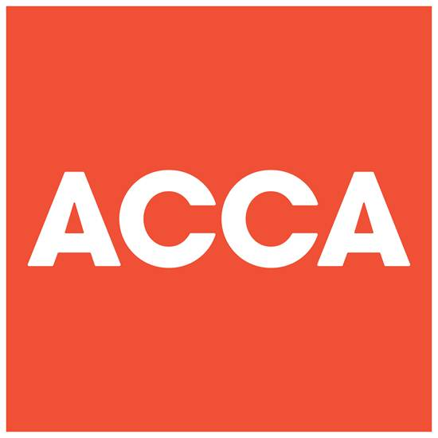

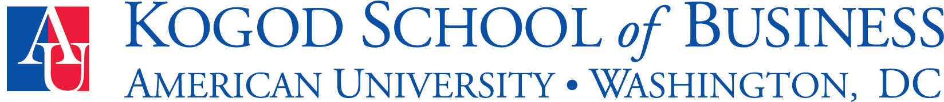

FOR IMMEDIATE RELEASE
July 8, 2015

ACCA USA and American University Partner to Prepare AU Graduate Accounting Students for ACCA Accreditation

(New York, N.Y.) – ACCA USA (the US arm of the Association of Chartered Certified Accountants) and American University today announced a partnership linking ACCA’s globally recognized qualification program to graduate coursework at the Washington D.C.-based higher education institution.

Starting this fall, students pursuing a Masters of Science in Accounting at American University’s Kogod School of Business will be able to complete coursework that will qualify them for six exemptions from ACCA’s 14 exams. A student who successfully graduates from American University’s rigorous program will receive exemptions for those specific exams and be able to use them towards the completion of the ACCA qualification.

“We are excited about our partnership with ACCA and looking forward to helping ACCA students become global leaders in the accounting profession,” said Casey Evans, Executive-in-Residence and Director of American University’s MS Accounting program.

“Across the globe, ACCA has forged partnerships with higher education institutions to educate and train some of the best and brightest accounting professionals,” said Warner Johnston, Head of ACCA USA. “We are proud to partner with American University on this initiative as we continue to train people of application, ability and ambition around the world who seek a rewarding career in accountancy, finance and management.”

The program is expected to attract a healthy number of international students interested in obtaining a degree while working towards their ACCA qualification. A recent ACCA survey of current students demonstrated an overwhelming interest in studying ACCA in the United States. Accreditation enables ACCA to award a specific level of exemption to graduates of an educational program following a full assessment of the program’s regulations, syllabus and assessments.

American University is home to more than 7,000 undergraduate students and nearly 3,500 graduate students, including more than 1,000 international students and scholars representing 137 countries. U.S. News & World Report’s America’s Best Colleges ranked American University’s Kogod School of Business as #23 in International Business Specialty in 2014 and Fortune Magazine and Money.com ranked Kogod as the #18th Best College for Earning a Business Degree in 2015.

American University is the second higher education institution in the United States to partner with ACCA USA. Earlier this year, ACCA USA announced its first U.S.-based partnership with Pace University’s Lubin School of Business in New York. Globally, ACCA works with more than 600 higher education institutions through Exemption Accreditation to accredit their programs, including Oxford Brookes University in England, University of Sri Jayewardenepura in Sri Lanka, Amity University in India, and Edinburgh Business School in Scotland.

ACCA qualified accountants have leveraged their education to hold impressive careers and work for many leading global employers at the C-suite level in positions including Managing Partners, COOs, CFOs, Executive Directors and CEOs. More than 35,000 ACCA members are employed by the Big 4 across the globe, with significant numbers in the United States, China and the U.K.

About ACCA (Association of Chartered Certified Accountants): ACCA is the global body for professional accountants with 170,000 members and 436,000 students in 180 countries worldwide. We aim to offer business-relevant, first-choice qualifications to people of application, ability and ambition around the world who seek a rewarding career in accountancy, finance and management. We work through a network of 92 offices and centers and more than 8,500 Approved Employers worldwide, who provide high standards of employee learning and development. Learn more at: www.accaglobal.com

About American University
American University is a leader in global education, enrolling a diverse student body from throughout the United States and nearly 140 countries. Located in Washington, D.C., the university provides opportunities for academic excellence, public service, and internships in the nation’s capital and around the world. Learn more at: http://www.american.edu

