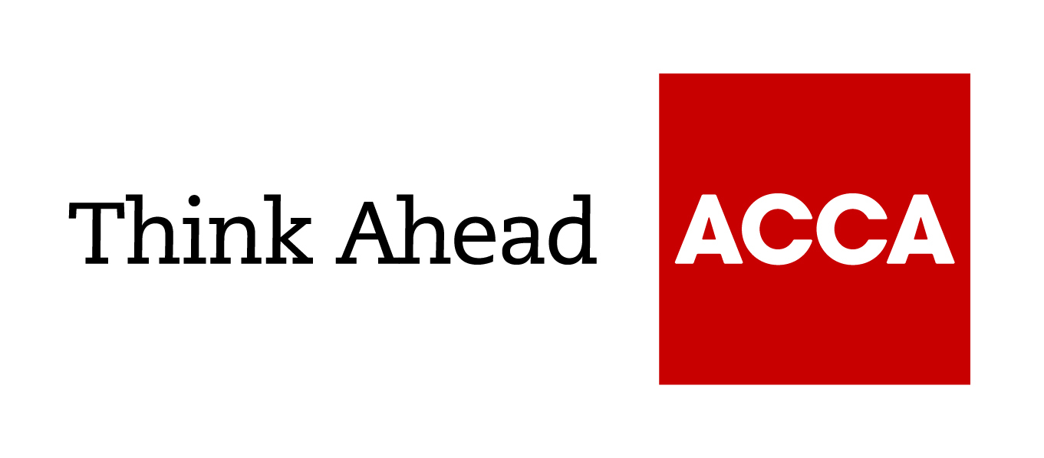

Guide from
[insert your firm’s name here]

Tel: [insert telephone number here] Email: [insert email address here] [Insert web address here]

[Insert a line about your business here]

Export finance

Exporting tends to be more demanding financially than selling in the UK. Consignments are usually larger, lead times are longer and the risks are more difficult to control. At the same time, you may need to take into account the problems of handling payment in foreign currencies.
Negotiating the terms of an export sale is a matter of balancing the risks and the costs to you and your customer.

1. Negotiating finance terms

The terms of an export sale must satisfy both you and your customer
You need to agree:
- The terms of delivery, covering the division of responsibility for transport costs and for the risk of loss or damage in transit. Standard international terms are set out in Incoterms 2020 (and the previous Version Incoterms 2010). Ask potential customers what terms they prefer and what causes them problems.
- The payment method. The customer's creditworthiness will determine what payment method you are prepared to accept.
- The currency you will be paid in (see ‘Foreign currencies’).

The price you negotiate needs to cover extra costs
- Transportation costs may include the cost of special packaging and labelling as well as the costs of any insurance you have to pay for.
- Documentation may involve special costs, beyond just issuing an invoice.
- You may have extra financing costs, depending on which financing options you use, and extra costs for dealing with foreign currencies.
- You need to agree who is responsible for taxes. It is common practice for each party to be responsible for their own country's taxes, but you can agree something different.

Assess the risks, and decide how much risk you are prepared to accept
- You may be prepared to use a less secure payment method if you know and trust your customer (or supplier).
- It can be difficult to recover goods or money through the courts if your counterpart fails to fulfil their obligations. You may want to assess their creditworthiness and reputation, and to research their country's business environment.

Plan your approach to negotiation
- Assess your negotiating strength. Your customer is usually in a stronger position than you are.
- Identify any normal practice you should follow. Within the EU, most established businesses expect to deal on open account in much the same way as within the UK.
- Some countries have legal restrictions, such as foreign exchange controls, which you must comply with.
- If your financing costs are lower than your counterpart's, it may make sense for you to take on more of the financing burden (and negotiate a price that reflects this).
- You might not want to invest time and money to be able to deal with foreign currencies or complex payment methods for a one-off export.
- Being more flexible can increase your competitive edge and may allow you to negotiate better prices.

Make sure you are clear on the documentation required
- You must provide all the documentation required by the purchaser and by the payment method you agree. For example, you might need to provide a certificate of origin as well as copies of the invoice and transport document.
- Export invoices generally need more detail than those for UK sales - such as a full description of the goods including item price, net weight (in kilos) and the country of origin and should be signed and dated.
- Goods for non-EU countries must be declared to HMRC before they are released for export, so export invoices and customs declarations must be prepared ahead of dispatch.
- Procedures for exports to EU countries may be affected by Brexit. Check the government guidance on preparing to export to the EU after Brexit.
- If you use a freight forwarder, they can handle much of the paperwork. Make sure you have a clear agreement on who is responsible for what.

2. Payment methods
The payment method you use has a significant effect on the financing you require and the level of risk to which you are exposed.

Open account payment is similar to offering credit to a UK customer
- Open account payment is typically used for exports within the EU and export sales to customers with whom you have an established relationship.
- Open account favours the customer. The goods are sent to the buyer without guarantee of payment. The supplier bears all the risk of offering credit and needs to finance the whole of the transaction.
- Make sure both parties are clear on when the credit period starts (typically, from the date the goods are despatched and the invoice issued).
- Within the EU, the standard default payment term is 30 days from date of invoice. However, businesses can agree a maximum payment term of 60 days.
- Check what normal payment practice is. In some non-EU countries, late payment is routine; in others, a late payer may face penalties. Plan in advance how you will chase late payment.

A documentary collection allows you to keep control of the goods
- Documentary collections are typically used for exports outside the EU to customers you have an established relationship with.
- You draw up a bill of exchange. An overseas bank, acting on your bank's behalf, will only release the documents necessary for your customer to take possession of the goods once they formally accept the terms of the bill.
- There is a risk that the bill of exchange will not be accepted. You still have ownership and control of the goods, but in your customer's country.
- There is still a risk that you will not receive payment after the bill is accepted. But you will have a strong basis for pursuing legal action against the customer.
- The bill of exchange specifies any credit period you are offering. You can specify immediate payment, payment after a set number of days, or payment by a given date.
- Once the bill has been accepted, you can use it to raise additional finance.
- Both your bank and the overseas bank will charge a commission. Your terms of trade must specify who is responsible for paying these charges.

Documentary credits (or 'letters of credit') are a more secure method of payment
- Documentary credits are typically used for exports to customers you have not sold to before, and for customers and countries that present particular credit risks.
- Your customer arranges a letter of credit with their bank (the 'issuing bank') which pays a correspondent bank in the UK (the 'advising bank'), once you submit all the necessary documentation.
- An accurate and authentic 'irrevocable' letter of credit, verified by your bank, carries little credit risk. As long as your documents are accurate, the issuing bank guarantees to pay you within the stipulated time.
- By 'confirming' the letter of credit, your bank agrees to pay you if the issuing bank defaults. Your bank will charge a commission based on how creditworthy the issuing bank is.
- The letter of credit specifies any credit period you are offering. A 'term' credit where payment is made after a set term (eg 30 days) will require you to finance the gap between delivery and payment.
- You can use a valid, current letter of credit to raise additional finance in a similar way to using a bill of exchange.
- Your customer is responsible for the cost of issuing the letter of credit. The customer will want to pass these costs on to you as part of the price negotiation.

You may be able to negotiate payment in advance for all or part of the shipment
- Payment or part payment in advance is typically used for low value sales to individuals or new customers.
- You have no risks and bear none of the financing costs.

You need to agree how funds will be transferred
- It is usually expensive to cash a cheque from a bank in a foreign country.
- Electronic payment systems are fast, straightforward and secure.
- A banker's draft or international money order can be cheaper, but takes longer and is less secure.

You can take out credit insurance against non-payment
- The level of risk depends on the payment method you have agreed.

Bills of exchange

A bill of exchange is a written document
- 'The drawer' (yourself) requires 'the drawee' to pay a specified amount.
- The drawee is usually your customer. If a bill is being used with a term letter of credit, the drawee is usually the customer's bank.

The bill specifies when payment should be made
- The bill can request immediate payment ('at sight' or 'on demand') or payment at a later date ('the term'), eg 30 days after sight.
- New exporters may find that their bank is not initially willing to provide them with term bills.

Drawees become legally liable for payment once they accept the bill
- A bill is often referred to as a 'draft' until it has been accepted.

'Negotiable' bills specify payment 'to the order of' the drawer
- This allows you to negotiate the bill, ie to sell it to another party (usually your bank) to raise finance.

3. Financing exports
Unless you have negotiated payment in advance, exporting may require additional financing. While you may be able to use a standard loan or overdraft facility, other options can be more cost-effective and provide access to greater amounts of working capital.
Each financing option, whether in pounds or a foreign currency, has different costs and cash flow implications. Explore your financing options before agreeing your terms.

You can arrange a foreign currency loan or overdraft
- You may be able to use proof of the export sale as security for the borrowing. Your bank may only accept this form of security if it has approved the customer, or if you purchase credit insurance.
- You exchange the money you borrow into pounds to use as working capital.
- You repay the borrowing with the payment you receive from your customer.
- If the customer fails to pay, you will be exposed to the additional risk that the exchange rate has moved against you.

You can sell a negotiable bill of exchange once it has been accepted
- Your bank (or another financial institution) buys the bill from you for a discounted value. The amount the bank pays depends on the currency, amount and term of the bill and the creditworthiness of the drawee.
- If the drawee is not known to your bank as creditworthy, the bill will have to be endorsed (ie guaranteed) by a third party - typically the customer's bank or a government agency. The third party will usually charge for this.
- The effective interest rate your bank charges on the financing will include a margin over interbank interest rates for that term in that currency. Typically, the margin for a bill that has been accepted by a high-quality drawee (eg a major bank) will be 1%-3%.
- The amount you sell the bill for will be paid to you in the currency the bill is denominated in.

You can use a bill to arrange additional borrowing
- The bill acts as security for a bank loan or overdraft facility.
- Financing can be arranged on a 'recourse' or 'non-recourse' basis. With 'recourse' financing, you have to repay your bank if the customer does not make the payment required by the bill.
- 'Non-recourse' financing will only be available if the bill has been accepted or guaranteed by an institution that is acceptable to your bank. Typically, this would be a major bank or a creditworthy government.

Forfaiting enables you to raise money on major transactions with staged payments
- You draw up a series of bills of exchange with different terms and can then negotiate them all at once.
- Forfaiting is usually used to finance high-value goods, such as construction projects.

An export factor can usually lend you more against an invoice than a bank
- Export factors specialise in collecting payment from overseas.
- Export factoring provides up to 80% of the value of each invoice once you issue it. You receive the balance upon settlement.
- Export factoring is generally only available for sales to countries where your annual exports are at least £100,000.
- The finance cost is usually 1%-3% above a standard rate for an overdraft.

4. Foreign currencies
Most customers will prefer you to quote and invoice them in their local currencies, rather than pounds. Unless you are prepared to do so, they may choose alternative suppliers. However, invoicing in a foreign currency exposes you to additional risks and costs.

You have a foreign exchange risk
- You are at risk from the moment you agree a sale in a foreign currency, until you have converted that amount of foreign currency into sterling.
- You are particularly at risk if the foreign currency is volatile or chronically weak, for example, in some Middle Eastern or African currencies.
- Some currencies present extra difficulties.

There will be an extra transaction cost and delay for converting the foreign currency
- With a 'spot' foreign exchange transaction, you sell a bank foreign currency in return for pounds.
- The cost of the transaction will be included in the rate you are quoted. For a £100,000 transaction in a widely traded currency (eg US dollars), the effective cost might be 0.5%.
- A spot transaction usually takes effect two business days after you agree the transaction price.

You can hedge against the risk of adverse exchange rate movements
- Using a 'forward' foreign exchange contract, you agree to sell the bank the foreign currency at a fixed future date for a price that is set now.
- The difference between the spot exchange rate and the forward exchange rate reflects relative interest rates between the two currencies.
- You must fulfil the forward contract, even if your customer does not pay you. You will then be at risk for any adverse movement in the currency.

You can buy an option to sell the foreign currency
- This gives you the right, but not the obligation, to sell the foreign currency at an agreed rate on the specified date.
- If exchange rates move against you, you use the option; if they move in your favour, you allow the option to lapse.
- You pay a premium for the option, which depends on the volatility of the currencies involved, relative interest rates and how far into the future the option covers you. A three-month option might typically cost you 2-5%.

It may be more convenient to maintain foreign currency accounts
- You may want to do this if you frequently issue foreign currency invoices. A foreign currency account can be particularly useful if you also need to make payments in that currency.
- You may receive interest on the balance in each foreign currency account. For amounts less than the equivalent of £100,000, the interest rate is likely to be substantially below the interbank rate.
- You can convert foreign balances into pounds sterling when you choose. Fewer, larger transactions will be cheaper and involve less administration than converting every payment received.
- If you regularly deal with customers or suppliers in a particular country, you may want to open a bank account in that country. This can make it cheaper to make or receive payments.

