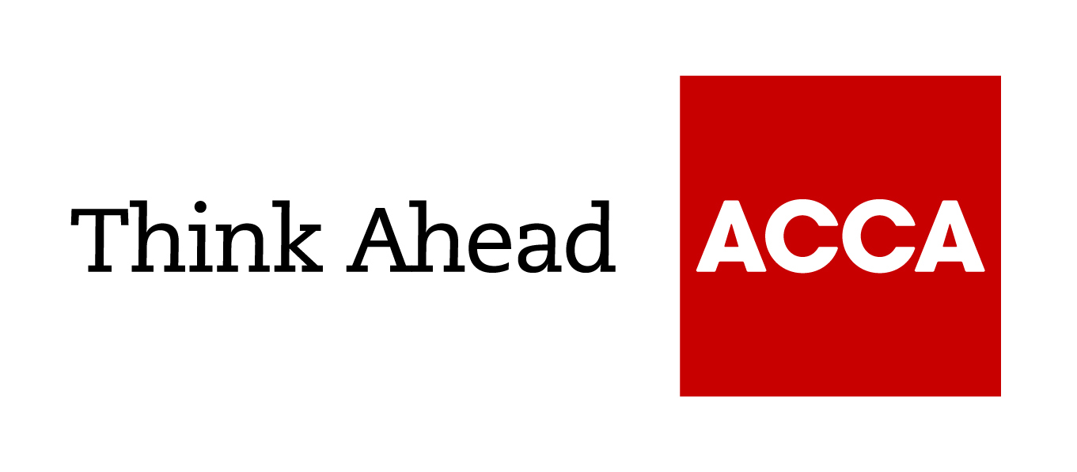

Guide from
[insert your firm’s name here]

Tel: [insert telephone number here] Email: [insert email address here] [Insert web address here]

[Insert a line about your business here]

Checklist: getting the right skills mix
Every business needs a range of employee skills to function effectively – from people management and development abilities to financial acumen, and from general sales and negotiation skills to specific industry knowledge.
- Carry out a training needs analysis to identify which skills you are missing and highlight areas where you need to develop staff.
- Ensure you have the essential business skills in place; some will be specific to your industry but others are required by all firms.
- Before recruiting, assess whether your existing staff have any untapped potential you could make use of.
- Bear in mind you might be unaware of an important skill if someone does not use it in their current role; training and developing existing staff can also improve job satisfaction and retention.
- Bring in skills and experience when hiring staff that will complement your current team rather than duplicate what you already have.
- Ensure that any new recruits can work as a team and understand your business goals.
- Consider alternative ways to bring in expertise – for example, is it cheaper to outsource than to recruit somebody full time or can you hire an external consultant?
- Invest in your own personal skills, as well as those of your staff. There are certain attributes that you as an owner and manager will have to develop, such as good leadership, communication and organisational abilities.
- Think about the skills you will need as your business develops, so recruit with an eye to how it might change in the future. For example, your IT or financial systems may become more complex.

July 2018

ACCA LEGAL NOTICE
This is a basic guide prepared by ACCA UK's Technical Advisory Service for members and their clients. It should not be used as a definitive guide, since individual circumstances may vary. Specific advice should be obtained, where necessary.

