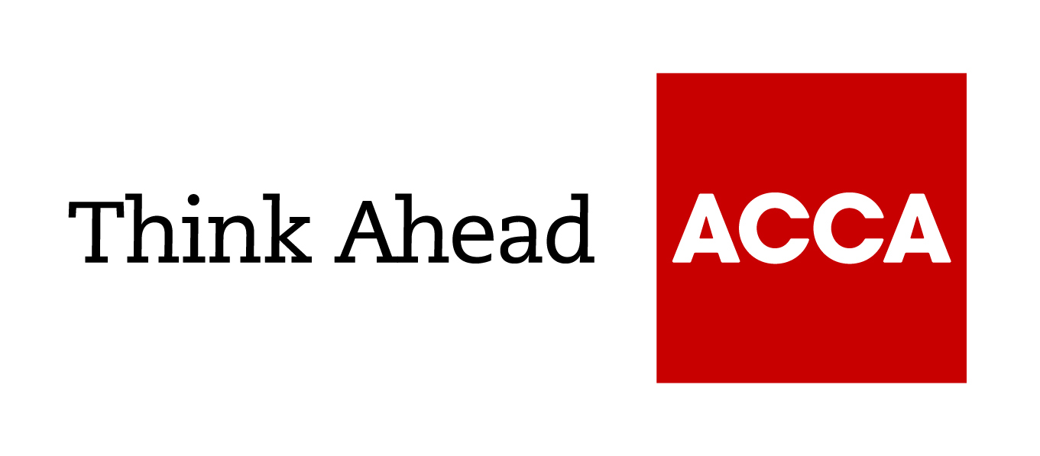

Guide from

[insert your firm’s name here]

Tel: [insert telephone number here] Email: [insert email address here] [Insert web address here]

[Insert a line about your business here]

Corporation tax reliefs and allowances

Corporation tax reliefs and allowances help you to minimise your corporation tax liability. It’s worth understanding the different ways in which the annual investment allowance, other capital allowances and allowable expenses are treated

Capital allowances and the annual investment allowance
Business expenses can normally be deducted from your income when calculating your taxable profit. But purchases of assets (eg machinery) are not allowable. Instead, you claim capital allowances.
Capital allowances can be claimed for most purchases of plant and machinery and business vehicles. In a few specific cases, you can claim capital allowances in relation to capital expenditure on premises, for example, by adding insulation. The government introduced the Structures and Buildings Allowance (SBA) for new, non-residential structures and buildings on 29 October 2018. The SBA allows a deduction from profits at an annual rate of 3% in 2020/21 (previously 2%) calculated on the original construction expenditure. Different types of expenditure qualify for different capital allowances.
If your total capital expenditure is less than a specified annual investment allowance (AIA), you can (in general) claim the full amount as a capital allowance in the first year. The AIA is set at £1m from 1 January 2019 for a period of two years (previously £200,000).
For capital expenditure over the annual investment allowance, capital allowances are claimed as writing-down allowances, allowing you to claim 18% for the cost of most plant and machinery each year (6% if special rates apply). The writing-down allowance on the special rate pool of plant and machinery reduced to 6% (previously 8%) from 1 April 2019 for businesses within the charge for corporation tax and 6 April for income tax.

Capital allowances and company cars
Special capital allowances rules apply in some cases. These include the capital allowances for company cars, which depend on the car's level of emissions, and capital allowances for short-life assets expected to last no more than four years.
Cars don’t qualify for the AIA; however, enhanced capital allowances are available for a few environmentally friendly technologies, allowing you to claim up to 100% in the first year.

Other assets that qualify for capital allowances
Other business costs treated as capital rather than overheads may also be eligible for capital allowances. These include:
- patents
- ‘know-how’
- research and development
- renovating business premises in disadvantaged areas.

HMRC capital allowances toolkits
These toolkits are aimed at helping businesses, as well as tax agents and advisers, by providing guidance on the common errors that can occur in identifying capital or revenue expenditure.
- HMRC capital v revenue expenditure toolkit (PDF)
- HMRC capital allowances for plant and machinery toolkit (PDF)

Allowable expenses
Ordinary business expenses can generally be set against profits, provided the expense is necessary and is wholly and exclusively for business purposes. There are a few exceptions where the expense is not allowable against tax, including entertainment and professional fees for company formation. However, you can get tax relief for charity or sponsorship payments. Your accountant can advise you on where exactly the line is drawn – for example, a staff uniform is an allowable expense but a suit is not.
Employers’ pension contributions made to a registered pension scheme generally are an allowable expense, but the same rule applies: the level of contributions must be justifiable in business terms. For example, HMRC might question disproportionately high pension contributions for the benefit of shareholding directors. As this can be an important area for personal tax planning, you should take advice.

Corporation tax reliefs
A number of other corporation tax reliefs can help reduce your corporation tax liability.
R&D tax relief
Corporation tax relief is available on qualifying research and development (R&D) costs. You do not have to be developing or creating leading-edge technology to claim R&D relief.
This allows you to both deduct these costs from your trading income and claim up to an additional 130% (230% in total) as a corporation tax relief to be deducted from trading profits. Loss-making companies can use this corporation tax relief to increase their losses and set against past or future profits or claim a cash tax credit. The rules vary slightly for large companies.
Patent Box scheme (intellectual property)
- Under the Patent Box scheme, companies with income attributable to qualifying patents, which they either own or have an exclusive licence to commercialise, only pay 10% corporation tax on that income. The profits must come from patent rights you sell or license, sales of patented products or products containing a patented invention, intellectual property infringement income or damages or compensation relating to your patent rights.
- Businesses electing to benefit can apply the 10% reduced rate to the appropriate percentage of relevant profits, starting at 60% in April 2013 and increasing to 100% of relevant profits from April 2017 onwards.
- You must make an election in your tax return within two years of the end of the accounting period to which the profits relate.
Loss relief
Different corporation tax relief is available if your company makes a loss. This corporation tax relief allows losses to be set against other income (eg from investments) or past profits, or carried forward to set against future profits. Group relief allows losses made by one company in a group of companies to be set against the profits of another group member.
Visit the GOV.UK website to download the HMRC company losses toolkit (PDF).
This toolkit is designed to help tax agents, advisers and anyone completing a Company Tax Return, avoid the common errors relating to company losses.

Brought to you in conjunction with Atom Content Marketing: offering practical advice to help small businesses succeed.

February 2021

