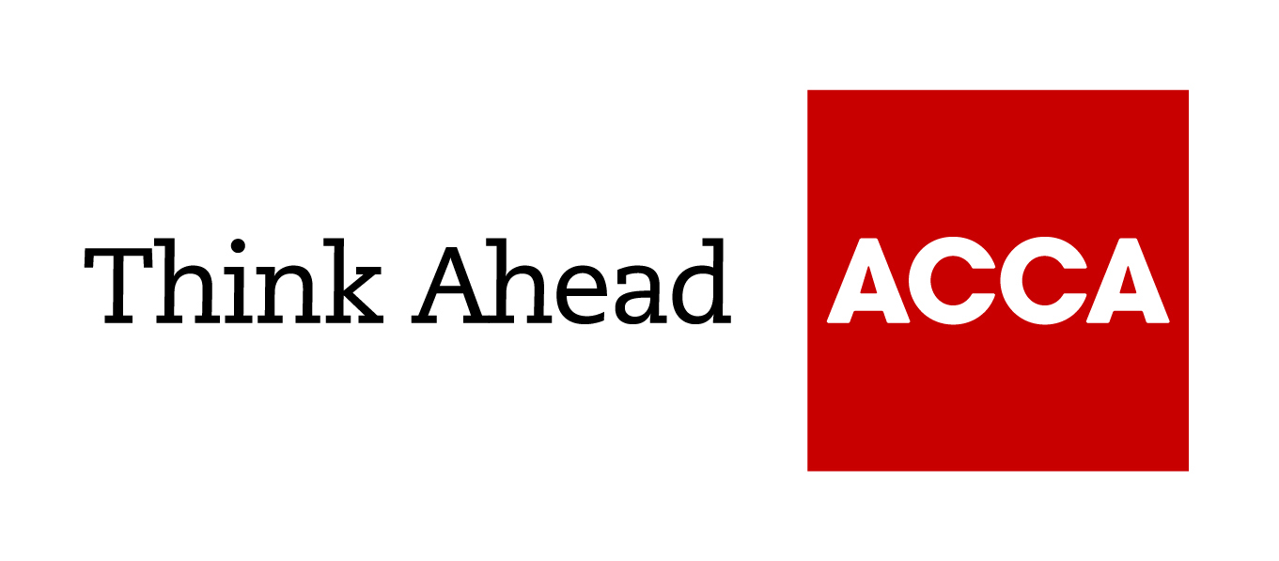

Guide from

[insert your firm’s name here]

Tel: [insert telephone number here] Email: [insert email address here] [Insert web address here]

[Insert a line about your business here]

Home expenses to claim when you're self employed: FAQs

13 FAQs people ask about expenses they can claim when running a business from home.
- What is an allowable expense?
- Won't my allowable expenses be similar to other businesses similar to mine?
- What factors are taken into account when apportioning an expense?
- Are heating, lighting and power costs allowable?
- Are telephone and broadband costs allowable?
- Can I claim insurance costs?
- Can I claim a portion of my council tax?
- Is mortgage interest allowable?
- What if I rent the property? Can I claim a proportion of my rent?
- Are repair and maintenance costs allowable?
- Can I claim for costs spent improving my home?
- What if my business operates mostly away from my home?
- Where can I get more information on home expenses?

1. What is an 'allowable expense'?
By law, an expense is allowable as a deduction only if it is incurred 'wholly and exclusively' for business purposes. It doesn't have to be billed separately nor does the part of your home have to be set aside permanently for business. For example, you can claim for allowable expenses for a room used as your office during work hours, but it must not be used for other purposes during that time.

2. Won't my allowable expenses be similar to other businesses similar to mine?
Not necessarily. People organise their businesses differently, so there is no fixed proportion of costs allowable for particular types of business. That said, the amount you seek to deduct as an allowable expense is expected to be similar to someone running a similar type of business in similar circumstances.

3. What factors are taken into account when apportioning an expense?
Area – how much of your home is used for business purposes? Usage – how much is consumed (eg where there is a metered/measurable supply such as electricity, gas or water). Time – how long is it used for business purposes.

4. Are heating, lighting and power costs allowable?
Where used wholly and exclusively by your business, yes, a proportion of the amount you pay is allowable. Obviously, that proportion will be determined by how much power your business consumes in your home. Some businesses use far more than others. A proportion of water charges are also allowable.

5. Are telephone and broadband costs allowable?
If used wholly and exclusively for business, yes. If used partially for business, a suitable proportion is allowable. An itemised bill will help when it comes to working out the cost of business calls made. Some of the monthly charges you pay to telephone/broadband providers is also allowable.

6. Can I claim insurance costs?
If you have separate business cover, this is allowed in full, but no part of your household policy is allowed in that case. If you don't have separate business cover, a suitable proportion of your domestic insurance is allowable.

7. Can I claim a portion of my council tax?
An appropriate proportion of your council tax bill is allowable, if part of your home is used exclusively for business some or all of the time.

8. Is mortgage interest allowable?
If part of your home is used solely for business some or all of the time, a proportion of the mortgage interest you pay is allowable. Repayments of capital are not allowable.

9. What if I rent the property? Can I claim a proportion of my rent?
Part of the rent you pay to a landlord is an allowable expense if part of your house/flat is used solely for business purposes for a proportion of the time you work. A sole trader cannot charge a separate rent to their business, because you cannot rent a property to yourself.

10. Are repair and maintenance costs allowable?
Yes, if you operate your business from your home some of the cost of general household repairs and maintenance is allowable. That might include redecoration of the exterior of the building or roof repairs. If a room is used solely for business, redecoration costs are wholly allowable.

11. Can I claim for money spent improving my home?
If you mean having an extension built or fitting a new kitchen, as examples, no, neither is an allowable expense.

12. What if my business operates mostly away from my home?
You can still claim deductions for allowable expenses generated when part of your home is used solely for business. A home-based office used for administration purposes is a common example.

13. Where can I get more information on home expenses?
You can get advice on allowable expenses if you are self-employed (including expenses incurred if you use your home for business such as premises, utilities, telephone and internet expenses) from the HM Revenue & Customs website. Alternatively, you can call HMRC's Self Assessment helpline on 0300 200 3310.
A good tax adviser will also be able to help you understand the essentials and help you claim all the expenses you are entitled to.

Brought to you in conjunction with Atom Content Marketing. Offering practical advice to help small businesses succeed.

