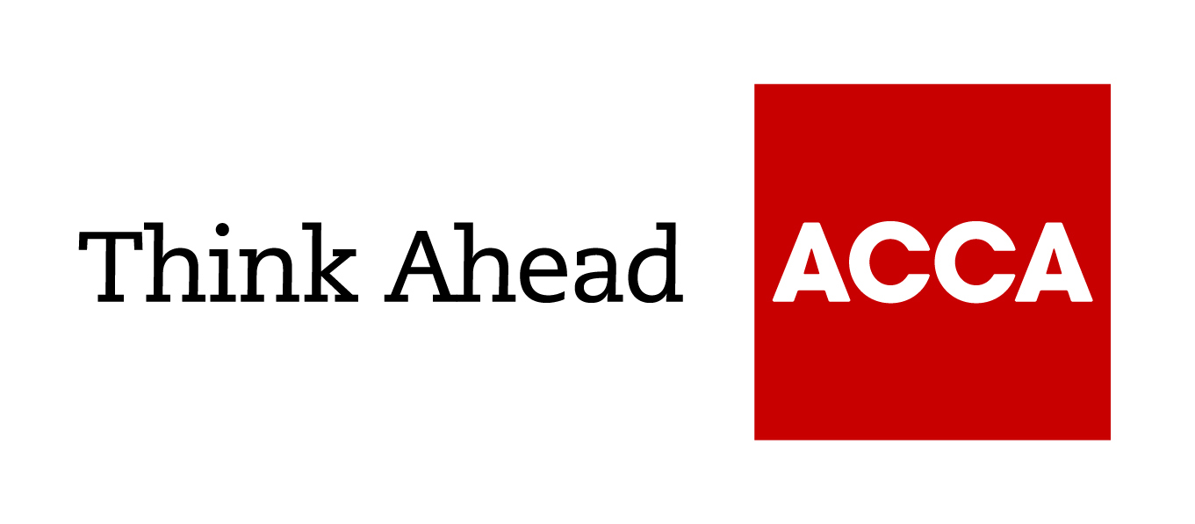

Guide from

[insert your firm’s name here]

Tel: [insert telephone number here] Email: [insert email address here] [Insert web address here]

[Insert a line about your business here]

Checklist: Staying within the law when using social media
The use of online social media platforms – such as Facebook, LinkedIn and Twitter – is a key part of most business marketing strategies. Most employees also use these platforms outside of work, and the crossover between personal and business use can be difficult to separate in a smaller business. The public nature of social media profiles and the speed at which online messages can go viral can also pose a serious threat to the reputation of a business. If in doubt, take legal advice.
- Assess the specific risks that apply to your business. Ask yourself: ‘whose use of social media could damage us, and in what ways?’ Tailor your approach accordingly.
- Understand how the different social media platforms work, how each distributes information. Read their terms and conditions.
- Make clear whether personal use of social media sites is permitted using company computers or mobile devices.
- Make it clear which employees have permission to post to social media sites on behalf of the company. Implement an internet or social media policy that makes it clear what can and can’t be posted, and establish a ‘company tone of voice’ for your social media profiles.
- Be aware of what your business publishes across the range of social media platforms, and put appropriate compliance and quality control procedures in place.
- If anything posted by your business may cause legal problems, remove it immediately. Potential problem areas include defamation, discrimination, obscenity, harassment, data protection, trade descriptions, IP rights, brand reputation and confidentiality of your sensitive business information.
- Make sure your business’s social media usernames don’t infringe any other businesses’ IP rights – for example, by using their business name or other trade marks.
…/continued overleaf
- To protect your IP rights, register any usernames related to your business name and other trade marks so they can’t be used by others.
- Change the login and password or remove access when staff leave so that they can no longer post on your profiles.
- Your business may be liable for damages caused by an employee’s personal social media posts – for example, if a customer’s personal data is revealed. Use your employee handbook, disciplinary procedures, internet policy and/or a separate social media policy to establish clear guidelines for employees.
- Set clear standards for public comments employees might make in their personal social media posts about your business, your other employees, your customers or your competitors. Consider the same potential legal problems listed above.
- If an employee breaches these standards, request the immediate removal of offending posts. If they refuse, you may be able to instruct the social media service to remove posts containing potentially unlawful content; take legal advice.
- Assess the importance to your customers of social media. In many consumer-facing businesses the relationship between brand and customer has been transformed.
- Have a plan in place to deal with negative customer posts. The potential speed and scale of distribution means that even a single disgruntled customer can have a potentially devastating impact.
- Don’t ignore or be heavy-handed towards customers who criticise you via social media: you may compound the reputational damage. An open and responsive approach is likely to prove more productive.
- However, if you believe a customer or other third party has used social media platforms to post unlawful or libellous content that adversely affects your business, take legal advice straight away.

