

Technical factsheet
Effective risk management

Contents
Page
1 Introduction 2
2 Background 2
3 Definitions 3
4 Risk management fundamentals 5
5 Thinking risk: the key concepts 10
6 Models and frameworks: best international practices 15
7 Governance and culture 18
8 Benefits of effective risk management 22

1 INTRODUCTION
Risk affects all organisations. It can have far-reaching consequences in terms of economic performance, environmental and safety outcomes, and professional reputation. Managing risk effectively and risk optimisation, therefore, will help enterprises of all sizes and in all business sectors to perform well in an increasingly uncertain environment.

Risk management has always been a feature of business. In the past, it was largely carried out in an informal way, relying on a combination of experience, instinct and luck. Today international best practice is to take a more systematic and disciplined approach; through better management and governance, organisations adopting risk management processes are more likely to survive and grow.

This factsheet explains what risk management is and the principles that underpin it. It reviews the risk management cycle, including measurement and documentation, together with key risk concepts. It also provides an overview of the most influential risk management models available today - although there are no legal or regulatory requirements for organisations to adopt these models, the factsheet summarises the benefits of doing so.

Most importantly, the factsheet encourages professional accountants to ‘think risk’. It shows through examples how effective risk management not only helps prevent loss and protect reputation but also enables better decision-making, thereby increasing the chances of meeting the business’s objectives.

2 BACKGROUND

Risk is an intrinsic part of doing business. Yet risk management – the formalised processes used today to identify, assess, prioritise, manage, mitigate, communicate and report on risk – is a relatively new business discipline.

The concept of risk management developed steadily throughout the 20th century out of a combination of wars, weather-related disasters, mathematical theories and business imperatives. The advantages of taking a disciplined approach to future uncertainties, based on probabilities rather than on luck or faith, became clear towards the end of the century. The title of chief risk officer was first used in 1993 by James Lam at GE Capital to describe a function that involved managing ‘all aspects of risk’. Peter Bernstein, in his influential book Against the Gods: The Remarkable Story of Risk¹ summarised this changed attitude: ‘If everything is a matter of luck, risk management is a meaningless exercise. Invoking luck obscures truth because it separates an event from its cause.’

Developments in risk management theory were encouraged and adopted by businesses. Driven by the insurance and financial services sectors in the US, by the end of the 1990s formalised processes were becoming the norm in many organisations. Risk management was embraced by private sector companies and the public sector alike around the twin goals of prudence and productivity. It enabled organisations to avoid unnecessary waste of resources at the same time providing them with assurance that objectives would be met in areas such as financial planning and health and safety.

3 DEFINITIONS
Risk management
There are many definitions of risk management. One of the earliest was contained in the first recognised risk management standard published in 1995 by the joint Australia New Zealand Standards Board²:

‘Risk management is a process to identify, assess, manage and control potential events or situations to provide reasonable assurance regarding the achievement of the organisation’s objectives.’

This remains one of the most helpful definitions and it contains two important ideas:
1 Risk management provides organisations with ‘reasonable assurance’ regarding outcomes, not with absolute assurance – there is no certainty in business.
2 The risk management framework should be established around the achievement of objectives. All enterprises exist to achieve certain things. These objectives should be identified and articulated by the board and senior managers. Risk is anything and everything that could impact upon the successful achievement of business objectives.

Risk
The International Organization for Standardization (ISO) produced an internationally recognised standard on risk management in 2009. ISO 31000:2009, Risk management – Principles and guidelines³ redefines risk as:

‘the effect of uncertainty on objectives’.

This simple definition provides a good insight into the true nature of risk. Significantly, it presents risk in neutral terms as the effect of uncertainty – a deviation from the expected that can have either a positive or a negative consequence on the achievement of objectives. If an organisation could only know for certain what is going to happen in the future then there would be no risk. Of course, this is not possible; risk exists, it cannot be wished away and so it has to be managed.

These two definitions point the way to what risk management is all about: it is a discipline for managing uncertainty. Organisations need to be aware always of both opportunities and threats when setting strategy and in their decision-making.

Example: Brexit
The UK’s referendum on membership of the European Union (EU) in June 2016 resulted in a majority of British citizens voting to leave. The implications for businesses are unclear and are likely to remain so for some time; it will take many years for the UK to disentangle from the EU.

Brexit is an excellent example of uncertainty providing both threats and opportunities to businesses. Consider the travel and leisure industry. The fall in the value of sterling after the referendum result might reduce demand by travellers for holidays abroad as costs go up, but it is likely to be good news for hotels, restaurants and tour companies providing holidays in the UK as foreign tourist spending is set to surge.

All organisations should be trying to identify and assess their own areas of exposure to Brexit risks. A failure to do so smacks of complacency and could be damaging. The sudden collapse into administration of Lowcost Travel Group in July 2016 illustrates the consequences of not managing Brexit risks; the holiday booking company failed to insure against currency movements and was therefore exposed to the collapse of sterling after the referendum⁴.

4 RISK MANAGEMENT FUNDAMENTALS
Small and medium-sized enterprises (SMEs), entrepreneurial businesses or sole practitioners are sometimes resistant to adopting a risk management process because they see it as bureaucratic – a tick-box exercise that takes up time and resources while adding little value. This is a misconception. The process should match the needs of the organisation, enabling it to identify and assess risk in a systematic way and put in place a proportionate response that is both efficient and effective.

Set out below are three straightforward mechanisms that can be adopted with advantage by all organisations: a way to measure risk around likely impact and probability; a means of documenting the risk management process; and, to begin with, a simple risk management methodology.

Risk management cycle
There are many ways that organisations can choose to manage risk today. The board (or equivalent) and senior management are responsible for designing and implementing the method that is most appropriate for each business.

In practice, many organisations use a five-stage risk management cycle similar to the one represented in diagram 1. The cycle is based on the approach set out in the Orange Book⁵, which provides a framework for the development and implementation of risk management processes in government organisations in the UK. First published in 2001, it was updated in 2004 and again in 2013, and has been highly influential, not only in the public sector. SMEs in particular can adopt the five-stage cycle with advantage. Many businesses supplying through a supply chain may wish to use the model and refer to this if questioned by larger end users on their Brexit planning.

The key components of the cycle are:
- Strategy. The strategy for managing risk is set by the board, including assigning responsibilities, approving policy and guidelines, and setting and communicating the corporate risk appetite
- Identification and assessment of risk. There should be distinct processes both to identify the risks and also to prioritise them; one of the most important outcomes is to highlight those risks that matter most to the business;
- Control assessment. Existing controls and monitoring procedures should be assessed; there are various ways to treat or mitigate risk including the application of internal controls, the use of insurance and contingency planning (eg disaster recovery)
- Measure, monitor and report. There must be a process to monitor the residual risk position (that is to say, the amount of risk remaining after the application of controls) and to report on progress
- An ongoing process. This is a dynamic process (represented by the arrows in diagram 1); risk management is not a static event that is looked at quarterly or, worse, only once a year.

Diagram 1: five-stage risk management cycle

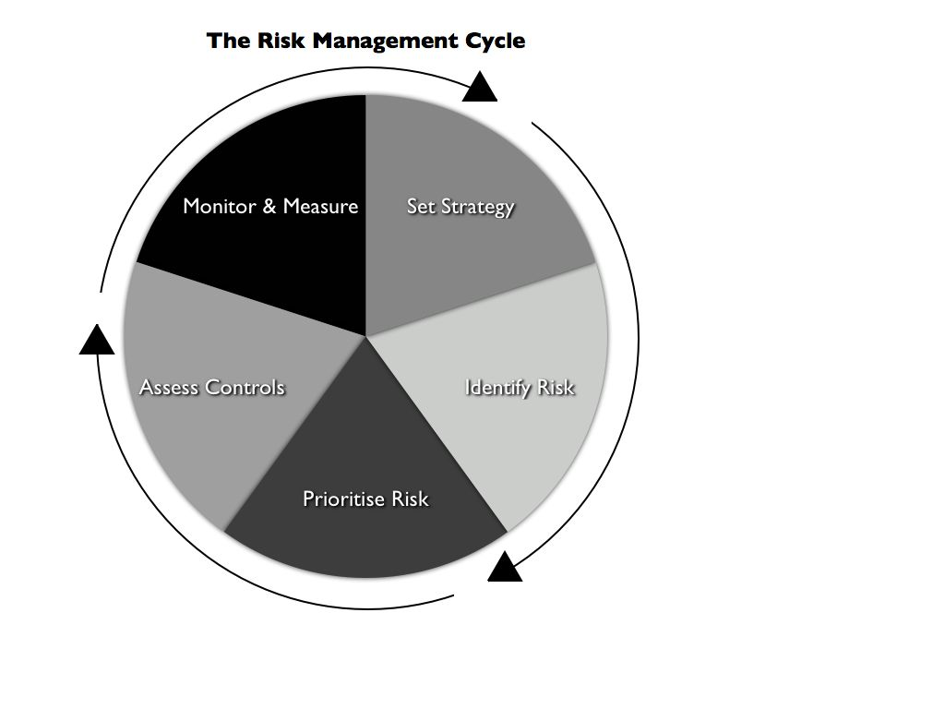

Impact and probability
It is crucial that organisations are able to prioritise their potential risks so that management attention and resources can be directed towards the high risk items. To do this, risk must be measured. The two key metrics in the measurement of risk are:
- impact (or severity). Impact is the measure of consequences – the severity of an event should it materialise
- probability (or frequency). Probability is the associated likelihood of an event occurring during a certain period of time.
The overall risk score is the product of the two metrics – impact x probability.

The risk measure used by organisations can be either quantitative or qualitative. The financial services industry has pioneered a quantified approach where risk is expressed in actual $ amounts. During the early 1990s the ‘quants’ at JPMorgan developed an innovative risk model called Value at Risk (VaR), which expressed risk as a single number. Other financial institutions followed suit and by the late 1990s VaR had become the industry standard. Other business sectors prefer to express risk in a qualitative way, often using a simple ‘high, medium, low’ scoring system. Either approach is acceptable, depending on business requirements. The important point is that the objective remains the same under both: to provide the business with a measure of risk that enables it to design a proportionate response, giving reasonable assurance that its corporate objectives will be achieved.

The risk register
One key differentiator between modern risk management and earlier approaches is evidence; today the process and the decisions arising from it must be documented. Failure to do so in areas of financial crime (eg anti-money laundering, anti-bribery policies) contravenes current laws and regulations, while a lack of evidence for decisions taken will render senior managers vulnerable to charges of negligence should their actions have poor consequences.

The most important and commonly used mechanism for documentation is the risk register.

The modern risk register has a variety of possible formats but all might be described as glorified Excel spreadsheets. Many use the ‘traffic-light’ system, whereby high, medium and low risks are represented by the colours red, amber and green respectively. Registers are often built around 3x3 matrices with impact and probability factors graded as high, medium or low, thereby providing a common reference point.

According to best practice, these registers should be ‘owned’ by managers and staff throughout the business. They are often compiled during workshops involving informed employees and should be updated regularly. Larger organisations will have a network of registers, with each main production, sales and service department being responsible for its own. There will also be a strategic risk register recording the most significant risks, owned and regularly reviewed by the board.

The design of these spreadsheets facilitates risk management in three ways:
- First, the identification and assessment of gross risk. The initial columns provide space for the identification of risks and their measurement in terms of impact and probability. This produces an inherent (or gross) risk score: a measure of risk BEFORE the application of controls and mitigating procedures.
- Secondly, focus on the residual risk score. Working across the spreadsheet, the next columns are used to set out the controls and monitoring procedures in place to manage each risk. These controls are assessed and graded as strong, medium or weak. Based on the combination of the size of the gross risk and the strength (or otherwise) of the controls, a residual (or net) risk score is produced: a measure of risk AFTER the application of controls and procedures. This is the key reference point. The register enables managers to ensure that the risk at any particular point in time is acceptable by keeping the residual risk score within the corporate risk appetite. Any high residual risks are highlighted as ‘red’ and must be reduced by actions to bring them within the risk appetite.
- Thirdly, action plans and timescales. The final columns of the spreadsheet are used to set out the action plans required to reduce any unacceptably high residual risks, together with the names of those responsible and the relevant timelines.

So, the risk register highlights controls gaps and provides evidence of decisions made. There are two important points for accountants regarding high-impact risk:

- Impact and probability scores have different implications. Probability risk can be reduced by the application of stronger controls. This is not possible for impact risk, however. High-impact risk requires alternative treatments: for example, the use of insurance to transfer a part of the risk away or contingency plans to handle a crisis.
- More focus is given today to potential high-impact events, especially hidden or underestimated threats that can cause serious damage. Examples include: fraud and corruption; cybercrime; brand damage, including social media; IT failures; and problems caused by third parties, where the root cause is often inadequate due diligence. The common theme here is potential reputational damage.

The risk register as described is an important part of the risk management process but it is not compulsory. It may be thought inappropriate for SMEs, or SMPs (small and medium practices); if so, an alternative form of documented process needs to be found. The risk register is effective because it enables the effective management of risk to take place at all levels in the business, while providing evidence of the process.

Example: the SMP
Bernard is an experienced professional accountant who has worked as a sole practitioner for many years, providing accounting and tax services to his clients. He knows the majority of his clients well, has kept up to date technically and runs a successful practice. He has read about risk management and attended conferences sessions on risk registers and other ‘best practices’. But Bernard has not implemented any of them and has no intention of doing so; he believes there is no need. Is he right?

Bernard is certainly correct that there is no requirement for him to make use of any particular process or risk management technique. However, there is an obligation under anti-money laundering regulations for accountants in practice to take a risk-based approach. This requires documentation, which must be kept up to date and available for inspection. Bernard does not need to use a computer-generated spreadsheet for this. But he should take the time to document his knowledge and assessment of the money laundering and terrorist financing risks in his business and the steps he takes to mitigate them.

It is also important to ensure that changes are documented. Recently the EU adopted a new legal framework to facilitate combating Isil and Al-Qaida, as well as persons and entities associated with or supporting them (eg through terrorist financing). This impacts all practitioners, who need to ensure that their policies and procedures are amended accordingly. Other changes include the new glossary codes that replaced the old codes, which are no longer be valid. From December 2016 the UK Financial Intelligence Unit will report on the progress made to the SARs Regime Committee, regulators, supervisors and suspicious activity report engagement groups. http://www.nationalcrimeagency.gov.uk/about-us/what-we-do/economic-crime/ukfiu

5 THINKING RISK: THE KEY CONCEPTS
Organisations need a structured, disciplined process to manage risk in the 21st century because the risk universe is now both complicated and interconnected. A review in the 1990s would have concentrated on two types of risk: financial and health and safety. Today, there are many different risk types, any one or combination of which could significantly affect a business. Examples are: reputational; financial; health and safety; strategic; technological; third party; ethical; environmental; legal and regulatory; credit; market; operational; competition; cyber; liquidity and solvency; geopolitical; contractual; and physical. They all have to be managed.

Professional accountants tend to focus on financial risk management and controls. Increasingly, with the trend towards more integrated risk management, they are becoming involved in managing non-financial risk areas, too, such as strategy, operations, technology and reputation. They must therefore be able to
- identify all types of risk in their business, its supply chain and local and global economies
- manage and mitigate those risks
- improve the strength of controls where required.

To succeed, accountants need to get into the habit of thinking risk. Best-practice models provide guidance but accountants need to understand the fundamental principles that underpin them. Set out below are five concepts that will help them to think risk.

Risk involves both threats and opportunities
Risk is uncertainty of outcome. If we know for sure what will happen in the future there is no risk and we can prepare for tomorrow with absolute assurance. But the future is always uncertain. In an uncertain business world, two things can happen: the threat of loss but also opportunities for gain. Success comes from managing both the positive and the negative aspects of risk effectively.

Accountants may associate risk primarily with threats: harm, hazards, events that cause damage. While it is always important to manage threats, the effect of concentrating on downside risk is sometimes to lose sight of the positives: the business opportunities. When organisations and managers are prepared to dare, to take a chance in pursuing their objectives, they are often rewarded with success. This is not to advocate being reckless or gambling with resources – not at all. Rather, it is about taking action when opportunities present themselves based on a careful assessment of all the circumstances. This is an integral part of what risk management is all about.

Example: business expansion
Company A is a small retail business in the physical fitness sector operating out of three stores in London with significant web-based sales, too. Brian, the managing director, has noticed the market trend for ‘functional fitness’ and sees opportunities to grow the business. He identifies two options: opening a new store in Manchester – he is not aware of any retail outlet offering functional fitness products there; and/or opening another store in New York – his instinct is to take advantage quickly of the explosion of interest in functional fitness in the US. Brian asks Helen, the finance director, for her view. Before giving it, she conducts a risk analysis.

Here, the risk – uncertainty – is whether there is sufficient market in functional fitness to operate a new store in Manchester and/or in New York profitably. Helen wants to identify and assess all relevant risks rather than relying on Brian’s gut feeling. Costs include: store costs (rent, rates, utilities etc); wages and salaries (especially store managers to oversee inventory and cash control); customer service; financing costs and insurance. Market research confirms that significant demand for functional fitness products exists: there is strong competition in New York, although Brian is correct that no rivals are operating stores in Manchester yet. Also, Helen identifies a risk that the strength of management control (physical presence) will be significantly diluted by opening in New York. There is greater uncertainty around both costs and revenue streams in New York. On the basis of her risk analysis, Helen recommends opening a new store in Manchester but not yet in New York. More research is required, and Helen recommends an alternative strategy of an online campaign to test the strength of the US market first. Brian accepts both recommendations.

In this example, Helen identified, analysed and evaluated the risks, each in their own context, in order to assess the overall impact on the objective of operating retail stores that are sustainable (ie can reliably produce a profit). She was able to assess the risks, discount where uncertainty remained and provide the analysis that enabled Brian to make a sound business decision.

Look to optimise risk, rather than minimise it
Every organisation needs to take an element of risk if it is to grow and achieve its objectives. So, while it is possible to seek to minimise risk in certain areas of business (eg around health and safety or a zero-tolerance of bribery and corruption) an overall strategy of risk minimisation is limiting and futile; risk exists and it must be managed.

There is advantage in going further and embracing the risk concept. Every enterprise should be looking not only to manage risk but to optimise it – to optimise the amount of risk it is prepared to operate with at any point in time. The reference point here is each organisation’s unique risk appetite – how much the business is prepared to put at risk in the pursuit of value. As with individuals, risk appetite varies from organisation to organisation.

This is an important point and one that is not always readily apparent. There is an additional by-product around positive effects. Promoting a risk optimisation strategy will help to change people’s perception of risk management, so that it becomes more of a motivational tool and less of an irritating box-ticking exercise that is seen to take up valuable time for little purpose. An organisation has a better prospect of building a risk-aware culture as a result.

Example: Bill Gates, Microsoft and the success of Windows
Bill Gates founded Microsoft with Paul Allen in 1975. In the early years their main product was the operating system MS-DOS, which they developed initially for IBM computers but were also able to sell independently. Although the performance of MS-DOS was poor, it was quite successful because of its low price and compatibility.

Allen left Microsoft in 1982 because of health problems. By 1985 Gates faced a key decision. MS-DOS was a slow system and was unable to make use of some major innovations in hardware, so it was only a matter of time before it was out-competed by other systems.

Because of the strong uncertainty in the operating software sector at the time, reliable foresight was not possible. This was a classic risk dilemma. Gates had several possibilities: sell Microsoft to one of its competitors; exit the operating systems market and focus on developing applied solutions; or invest in a new operating system.

This last option carried the greatest downside risk: it was expensive, the resources of Microsoft at the time were small compared with competitors like IBM and Apple; and failure would have meant the end of the company. But it also offered significant opportunities: there was no technical standard set for the new generation of computer systems and if Microsoft could achieve ‘first-mover’ status it would be able to secure long-term monopoly revenues.

Gates was not reckless; he hedged his bets for some time: for example, by starting a joint venture with IBM and also developing some applications for the Apple operating system. However, he did invest in the development of the Windows system. Although in the first years Windows sold poorly and suffered some serious technical flaws, by the early 1990s it turned out to be the lead product in the operating systems market, defining the new technical standard. Microsoft Windows came to dominate the world’s personal computer market with over 90% market share.

Understand the linkage between risk and controls
Professional accountants are familiar with internal control frameworks but sometimes the relationship between controls and risk is unclear.

Risk drives controls, not the other way round. Internal controls exist for many reasons but one of their prime functions is to manage risk. It is impossible, therefore, for any organisation to have an efficient and effective internal controls system unless it is based on a thorough, systematic and ongoing assessment of risk in the business.

This applies particularly to control design, where the key reference point is risk. The basic equation is simple: the higher the risk, the stronger the controls needed to mitigate it will be; conversely, low or medium risk will require modest controls only.

This leads to the key observation that a risk-based approach is a proportionate approach involving the efficient use of an organisation’s resources. For example, it would be poor management to allocate oversight of a major outsourcing contract to an inexperienced or junior member of staff. One of the essential characteristics of a ‘strong’ control is senior management sign-off, so it would be appropriate here to have a senior manager overseeing the outsourcing contract. Conversely, it is an often-made mistake for a business to spend valuable time and resources trying to manage areas of low risk.

Be aware of the risk/controls time lag
Risk is dynamic; it changes all the time. Internal controls are not dynamic, however. In many organisations, especially mature businesses, systems and procedures have evolved slowly over time. They may be characterised as essentially historic, remaining ‘anchored in the past’. So, gaps can appear between risks, which are changing, and controls, which are slow to react to the changes. There is real danger for all businesses if these control gaps grow too wide.

Example: cybercrime
Nowhere are the potential dangers of the risk/control time lag better illustrated that in the area of cybercrime. Peter Goldsmith, as attorney general, commissioned the original Fraud Review in the UK in 2006. Commenting to the Fraud Advisory Panel on how fraud risk has changed over the decade since the review, he highlighted the importance of cybercrime, which was not even on the Fraud Review radar 10 years ago⁶. Since then, the internet has industrialised the way crimes of deception are committed.

Cybercrime is now a national security threat and vulnerabilities are everywhere. Many organisations have fallen victim because their cybersecurity controls (from anti-virus software to effective passwords to awareness of the dangers of fraudulent emails and infected downloads) have lagged behind the changing nature and scale of the threats.

Avoid a tick-box attitude
Finally, a word of warning for those accountants in larger organisations looking to put in place comprehensive, detailed risk management systems, including policies, registers and regular reporting. These systems will not be sufficient to drive improvements or add value unless they are accompanied by intelligent review and analysis of what the data is saying about the business and its risk profile. There is a danger of becoming obsessed with the detail of the process, where the focus is hitting reporting deadlines in order to tick a box. This is not effective risk management.

6 MODELS AND FRAMEWORKS: BEST INTERNATIONAL PRACTICES
Best-practice models and frameworks for risk management and controls have been developed from the early 1990s onwards. They focused initially on internal controls, although always with a linkage to risk. More recent models have used risk as the primary driver, with a broad enterprise-wide scope and an integrated approach to risk management.

The first controls model was the Internal Control – Integrated Framework⁷ published in the US in 1992 by the Committee of Sponsoring Organisations of the Treadway Commission (Coso). The Coso controls framework provides principles-based guidance for designing and implementing effective internal controls. Crucially, it provides a standard against which businesses and other entities – large or small, in the public or private sector, for-profit or not – can assess their control systems and determine how to improve them. The framework was reviewed and revised in 2013 and is widely used in the US and around the world.

There are two other important controls models, each set in a corporate governance context. In 1999 in the UK, Nigel Turnbull’s report, Internal Control: Guidance for Directors on the Combined Code⁸, introduced a simple and powerful four-stage framework:
- stage 1: identify and assess risks
- stage 2: design controls
- stage 3: test controls
- stage 4: board oversight and reporting

Although applying to listed companies, the Turnbull guidance has been very influential in the UK. The updated version still provides important assistance for directors under its new title, Risk management, Internal Control and Related Financial and Business Reporting.⁹

The second model is contained in in the US statute, the Sarbanes-Oxley Act 2002 (SOX). The SOX introduces major changes to the regulation of corporate governance for all companies listed on one of the US stock exchanges, wherever located around the world. The law was passed as a direct response to investor concerns arising from the bankruptcies of Enron and WorldCom following large-scale accounting fraud by senior executives. The SOX mandates stronger internal controls over the financial reporting process. It requires the management of public companies to certify and the independent auditor to attest to the effectiveness of those systems. There are new duties and significant penalties for non-compliance.

More recently, the focus of international best practice models has shifted from internal controls to risk management. We saw earlier the influence of the Orange Book, first published in 2001 in the UK. Since then, a number of other risk management frameworks have been produced. Three of the most important are described below:

- ISO 31000:2009, Risk management – Principles and guidelines¹⁰
This international standard provides principles, framework and a process for managing risk. It can be used by any organisation regardless of its size, activity or sector. Using ISO 31000 can help organisations increase the likelihood of achieving objectives, improve the identification of opportunities and threats, and effectively allocate and use resources for risk treatment. Importantly, organisations using it can compare their risk management practices with an internationally recognised benchmark.

In 2015 ISO published related guidance, this time specifically designed for SMEs looking to improve their risk management practices: ISO 31000 Risk management – a practical guide for SMEs.¹¹ The guide aims to be a practical and beneficial resource for SMEs, helping them to align their practices according to the international standard, thereby improving their competitiveness and increasing their participation in international trade through better recognising and managing their risk portfolio.

- Coso Enterprise Risk Management – Integrated Framework¹²
This ERM model provides a robust and extensive focus on the broad subject of enterprise risk management (ERM). It was published in 2004, having been developed in the US against the background of the Enron and WorldCom accounting scandals. It does not replace the earlier Coso Controls Framework but rather incorporates that framework within it. The ERM framework defines essential risk management components, discusses key ERM principles and concepts, and provides clear direction and guidance. One important aspect is its discussion of risk appetite, which should help managers to meet the challenge of determining how much risk their entity is prepared to accept as it strives to create value.

The Coso ERM model has become a widely accepted framework and is now established as a model that can be used in different environments worldwide. One advantage is that it provides a framework against which risk management systems can be assessed and improved (in the same way as the ISO framework).

Three Lines of Defence model
Following extensive discussions in the financial services industry arising out of the risk management and governance failures of the global financial crisis, the Three Lines of Defence model was developed by the Institute of Internal Auditors in 2013¹³. The concept is widely used today in the banking and insurance sector as a risk management framework and as a benchmark for assigning control and risk management responsibilities to business functions. It does not have general applicability beyond financial services, however.
The model is relatively straightforward. The first line of defence is business line management; as we saw earlier, risk is managed most effectively if it is owned by the revenue-generating business units themselves. The second line is risk oversight provided by a separate risk management function (or others such as compliance). The third line of defence is an independent review and challenge process, traditionally carried out by the internal audit function.
There is actually a fourth, governance-related dimension to the model. All three lines of defence have reporting lines to either the board itself or to a board committee (the risk or audit committee). There is therefore effective oversight of risk in the model, which also promotes the efficient co-ordination of control responsibilities.

These models (and others such as the Basel Capital Accords) set out international best practices in risk management. They do not provide a panacea, however. All are vulnerable, in particular in two areas: first, technological failure, such as software glitches or back office shortfalls; and, secondly, ‘people risk’ – error, poor judgement, complacency, negligence or malign intent.

The best way to manage people risk is by combining the systems and processes discussed above with effective governance and tone at the top to create a risk-aware culture.

7 GOVERNANCE AND CULTURE
Governance is what the board (or equivalent) of an organisation does and is different from day-to-day operational management. It includes setting values, the oversight of strategy, supervising managers and ensuring that risk is managed effectively.

We look at two aspects of risk governance below: creating an effective responsibility framework for risk management; and building a risk-aware culture to protect reputation.

Responsibility framework
Effective risk management can best be achieved if there is clear awareness throughout the organisation of responsibility at three levels: the board; line managers and departmental heads; and individual members of staff. The resulting framework is illustrated in diagram 2 below.

Diagram 2: responsibility framework
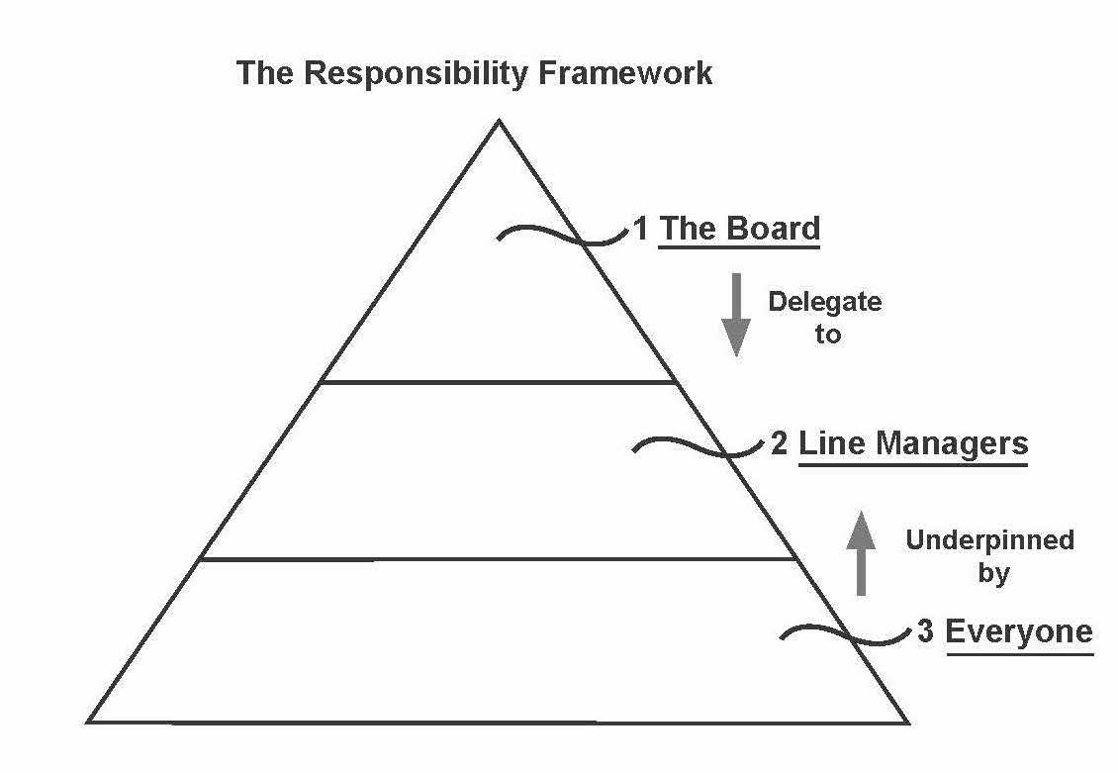

Awareness and discharge of responsibility at each of the three levels is crucial and the key areas are highlighted below.

The board
The people at the top establish the values of an organisation and set policy. Ultimate responsibility for managing risk and for putting in place an appropriate system of internal controls resides with the board. This is made clear in the UK Corporate Governance Code¹⁴ where the Main Principle in Section C2 on risk management and internal control states:

‘The board is responsible for determining the nature and extent of the principal risks it is willing to take in achieving its strategic objectives. The board should maintain sound risk management and internal control systems.’

The board has specific responsibility for two different aspects of risk management. First, it owns the principal risks: those that can seriously affect the performance, future prospects or reputation of the organisation, including threats to its business model, solvency or liquidity. Secondly, it must ensure the ongoing adequacy of the risk management and internal control systems.

Although the code applies to companies listed on the London Stock Exchange, it provides a clear signpost of best practice. The main principle on risk management and internal control can be adapted and applied with advantage by all organisations, regardless of size or business sector.

As always with a risk-based approach, the discharge of these responsibilities should be evidenced, primarily in policies and board minutes.

Line managers
The board delegates to managers, whose role is to implement board policies. Managers should identify and assess the risks faced and design, operate and monitor a suitable system of internal control which implements the policies of the board.

One of the key principles of modern risk management is that risk should be owned by the managers working in the business itself – the ‘first line’ in the Three Lines of Defence model that we looked at earlier. Line managers, departmental heads and team leaders play a crucial role, therefore. If risk management is to be effective, then the maxim ‘risk devolves to the line’ must work in practice. Measures to promote this include a clear statement of responsibility for risk management in managers’ objectives and performance assessment, and remuneration packages designed to provide incentives for managers to focus on their risk management responsibilities.

Many businesses today employ risk specialists. In financial services, for example, there is likely to be a chief risk officer, supported by a risk team. One of the key recommendations of the Walker Review¹⁵ (set up in 2009 to look into the governance failings of banks and other financial institutions during the global financial crisis) is that the board should be served a chief risk officer of sufficient calibre and independence to participate in the risk management and oversight process at the highest level. Risk specialists feature in the public sector, too, where many organisations employ a risk co-ordination manager.

Whatever their title, these risk specialists have an important role to play in managing risk but they do not work in isolation. The board should be looking to a broad category of business managers to manage risk day to day.

Everyone
All employees have some responsibility for risk management and internal control as part of their accountability for achieving their personal objectives. It is important that everyone understands this and knows what is expected of them. Some training and awareness-raising will be required to make this happen. For example, junior or inexperienced staff members are likely to equate risk management with health and safety risk assessments – an important part of risk management, but only a part.

The participation of everyone is essential because it underpins the entire responsibility framework. It also enables a risk-aware culture to permeate throughout the organisation; this, in many ways, is the holy-grail of risk management.

Risk-aware culture
The culture of a business is as important as the processes it uses in determining how successful it will be in managing its risks. The most significant influence on organisational culture is the behaviour and decision-making of the directors and senior managers – the ‘tone at the top’.

The tone at the top is crucial in creating a risk-aware culture that is proactive (rather than reactive), accountable (rather than riddled with blame), integrated (not in silos) and effective (not bureaucratic). Key components include: consistent decision-making in line with risk appetite and values; bonuses and incentives tied to risk; investment in awareness-raising; and the communication and reporting of risk issues.

An important by-product of developing a risk-aware culture is the assurance it gives around the management of reputational risk. This is crucial for all accountants, both as professionals and as managers in business. The demise of the global accounting firm Arthur Andersen, arising out of its business relationships with Enron, provides the ultimate example of the consequences of damage to reputation.

The accountant must be aware of the expectations of key stakeholders, such as customers and regulators, in order to manage reputational risk successfully. These expectations can change over time. The issue of tax avoidance is a good example, with the authorities now looking at naming and fining accountants (and other advisers) who design or market tax avoidance schemes deemed unlawful by a court.

The accountant has a trusted role in society and in business based on a combination of competence and integrity. One essential feature of integrity is being law-abiding; another is consistency of conduct and performance – being straightforward and behaving honestly and fairly at all times, not only when it is convenient to do so. The ACCA Rulebook¹⁶ provides the essential reference point here.

8 BENEFITS OF EFFECTIVE RISK MANAGEMENT
The benefits of having a risk management process aligned to best international practices are most obviously seen in large enterprises. Here it will increase the confidence of stakeholders in corporate governance and the ability of those at the top to deliver on corporate objectives.

The effective management of risk depends on culture and awareness as much as on process, and there are significant advantages for all organisations if this can be achieved including:
- enabling informed decisions about exploiting opportunities while constraining threats to acceptable levels
- providing consistency, visibility and evidence of decisions taken
- finding fewer surprises because issues are highlighted more quickly
- promoting increased understanding and ownership of risk throughout the business.

Professional accountants are well placed to contribute to the effective management of risk in their businesses. By always ‘thinking risk’, they will improve their decision-making, thereby increasing the chances of achieving objectives and adding value.

REFERENCES
1 Bernstein, P. (1996). Against the Gods: the Remarkable Story of Risk, John Wiley & Sons.
2 AS/NZS 4360:1995
3 www.iso.org/iso/home/standards/iso31000.htm
4 http://www.bbc.co.uk/news/business-36810558
5 https://www.gov.uk/government/publications/orange-book
6 https://www.fraudadvisorypanel.org/wp-content/uploads/2016/06/The-Fraud-Review-Ten-Years-On-WEB.pdf
7 www.coso.org/ic.htm
8 https://www.frc.org.uk/getattachment/5e4d12e4-a94f-4186-9d6f-19e17aeb5351/Turnbull-guidance-October-2005.aspx
9 https://www.frc.org.uk/Our-Work/Publications/Corporate-Governance/Guidance-on-Risk-Management,-Internal-Control-and.pdf
10 www.iso.org/iso/home/standards/iso31000.htm
11 www.iso.org/iso/iso_31000_for_smes.pdf
12 www.coso.org/-erm.htm
13 https://www.iia.org.uk/threelines
14 https://www.frc.org.uk/Our-Work/Codes-Standards/Corporate-governance/UK-Corporate-Governance-Code.aspx
15 http://webarchive.nationalarchives.gov.uk/+/http:/www.hm-treasury.gov.uk/d/walker_review_261109.pdf
16 http://www.accaglobal.com/hk/en/member/professional-standards/rules-standards/acca-rulebook.html

ACCA LEGAL NOTICE
This technical factsheet is for guidance purposes only. It is not a substitute for obtaining specific legal advice. every care has been taken with the preparation of the technical factsheet, neither ACCA nor its employees accept any responsibility for any loss occasioned by reliance on the contents.

