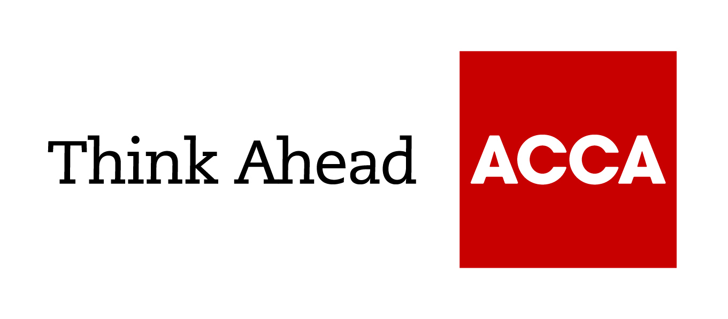

Guide from

[insert your firm’s name here]

Tel: [insert telephone number here] Email: [insert email address here] Website: [Insert web address here]

[Insert a line about your business here]

VAT accounting schemes

VAT accounting schemes can make your life easier, simplifying your VAT accounting and in some cases improving your cashflow. If your taxable turnover of standard and reduced-rated supplies is below £1.35m (excluding VAT), or if you are involved in retail or selling second-hand goods, a VAT accounting scheme could suit you.

VAT flat rate scheme
The VAT flat rate scheme simplifies your VAT returns. You simply calculate the VAT due to HMRC as a percentage of your turnover. This is instead of paying the difference between the actual VAT you have charged on sales and the VAT you’ve paid out on purchases. The only input VAT you can claim is on the purchase of a single capital item of expenditure costing more than £2,000 including VAT. You list this separately on your VAT return in box 4.
The flat rate used depends on your industry and has been set at a level where you should end up paying HMRC virtually the same amount of VAT as if you had carried out the full calculation. If your purchases are significantly higher than expected for your industry, it might not be the scheme for you. There is a 1% discount if you use the scheme during your first year of VAT registration.
You are only eligible for this scheme if your estimated taxable turnover in the next year will be no more than £150,000. Once you are using the scheme, you can continue to do so until your total business income exceeds £230,000.

Limited cost trader
Businesses using the VAT flat rate scheme that fall within the definition of ‘limited cost trader’ must pay VAT at the enhanced rate of 16.5%. The rule applies if the cost of direct goods and services is less than 2% of turnover or less than £1,000 per year (even if costs are more than 2%). There are restrictions on the goods and services you can include for this calculation when deciding if you are eligible to stay on a lower rate. Many business expenses are excluded such as capital expenditure, professional services and vehicle running costs.

VAT cash accounting scheme
Normally, VAT returns are based on the tax-point date (usually the same as the VAT invoice date) for your sales and purchases. This may mean you can end up having to pay HMRC the VAT due on sales that your customers have not yet paid for.
The VAT cash accounting scheme instead bases the return on payment dates, both for purchases and sales. You will need to ensure that your VAT records include a record of actual payment dates.
You are only eligible for the VAT cash accounting scheme if your estimated taxable turnover is no more than £1.35m; you can then stay in the scheme as long as it remains below £1.6m.

Annual accounting scheme
The annual accounting scheme allows you to pay VAT on account, in either nine monthly or three quarterly payments. You then complete a single, annual VAT return, which is used to work out any balance owed by you or due from HMRC.
Again, this simplifies your VAT paperwork. You are only eligible for the scheme if your estimated taxable turnover is no more than £1.35m; you can then stay in the scheme as long as it remains below £1.6m.
If eligible, you may be able to combine the annual accounting scheme with the VAT flat rate and VAT cash accounting schemes.

Retail and VAT margin schemes
Various retail schemes exist to simplify VAT. The right scheme for you depends on whether your retail turnover (excluding VAT) is below £1m, between £1m and £130m or higher.
Smaller businesses may be able to use a retail scheme with cash accounting and annual accounting. You cannot combine a retail scheme with the VAT flat rate scheme, but retailers can choose to use the flat rate scheme instead.
Separately, there are VAT margin schemes for businesses that deal in second-hand goods, art or similar goods, as well as a special tour operators’ margin scheme.
You may want to take advice to see which scheme would best suit your circumstances.

VAT reverse charge scheme
From 1 March 2021 a new VAT reverse charge scheme for the construction industry applies, in order to tackle widespread ‘missing trader’ fraud.
The reverse charge scheme makes the customer, instead of the supplier, responsible for accounting for VAT on providing labour.
The scheme doesn’t apply to the final business or domestic customer but does apply to sub-contractors who supply workers to a main contractor.

Brought to you in conjunction with Atom Content Marketing: offering practical advice to help small businesses succeed.

April 2021

ACCA LEGAL NOTICE
This is a basic guide prepared by ACCA UK's Technical Advisory Service for members and their clients. It should not be used as a definitive guide, since individual circumstances may vary. Specific advice should be obtained, where necessary.

