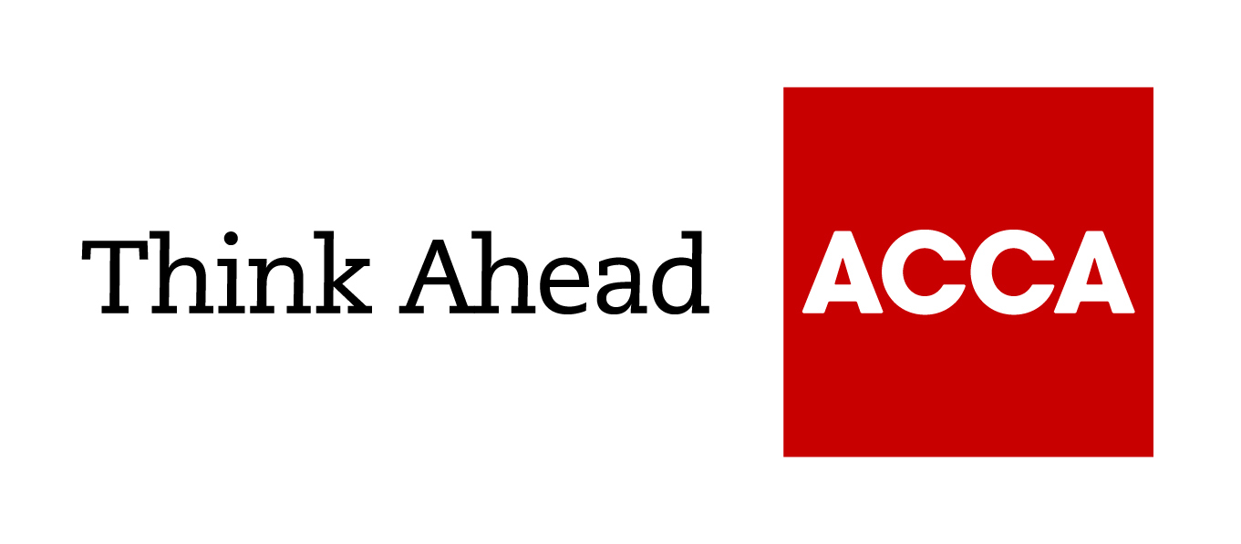

Guide from
[insert your firm’s name here]

Tel: [insert telephone number here] Email: [insert email address here] [Insert web address here]

[Insert a line about your business here]

Your money and your business

As the owner-manager of a small or medium enterprise, your own financial affairs are likely to be closely entwined with the way you run your business.
You should think about how the business will affect your own finances from the moment you start up and continue to keep this in mind throughout its lifecycle.

1. Structuring your business
The legal form of your business will affect your financial position.

Unincorporated businesses
- Sole traders, partnerships and limited liability partnerships give you the flexibility to withdraw funds for personal use at any time.
- Profits are mainly taxed as income in unincorporated businesses. They are good if you do not want to retain profits in the business, and just want an income and some kind of pension.
- National Insurance contributions (NICs) are generally lower than if you are an employee of a limited company.
- Sole traders and members of a partnership have unlimited liability for business debts.
- A limited liability partnership (LLP) lets you limit your liability. While strictly a corporate vehicle with legal requirements similar to those of a limited company, an LLP is generally taxed as an unincorporated business.
- Partnerships are flexible arrangements which make it easy to share large profits between family members. You do not have to justify a spouse or civil partner's level of remuneration to HMRC as you would with a company.

Limited company
- Forming a company (incorporation) may be the right option if you want to retain profits and build capital value in the business.
- Corporation tax payable on a company’s profits will generally be lower than comparable income tax liabilities.
- You can pay yourself a combination of salary and dividends (see ‘Extracting profits’).
- Dividends are paid out of after-tax profits on which corporation tax of 19% (since April 2017) has been charged. But shareholding employees still generally pay less total tax and NI on dividends than on the same amount paid to them as wages.
- Legislation aims to prevent individuals diverting income to another person to gain a tax advantage.
- You may have to incur extra costs such as for audits and filing requirements at Companies House. By filing accounts, you are making information publicly available which would otherwise be private.

2. Financing your business
Aim to structure borrowings for maximum tax relief. Consult your accountant or tax adviser.

Always look at the security of any borrowings you make
- If you are borrowing to invest in your business and it is a high-risk venture, you probably shouldn’t do it. Can you afford to lose what you are providing as security - particularly if it is your family home?

Taking out a domestic mortgage can be a cheap way of raising capital
- You can raise money from a mortgage or second mortgage on your property and then lend the money to the business.
- Interest rates are lower than for conventional business loans.
- Some mortgages give you the flexibility to vary repayments according to your changing financial circumstances. You may be able to overpay or underpay or take payment holidays.
- One catch is that there is no mortgage interest relief in the UK.

Business bank loans are still relatively cheap
- But make sure you will be able to cope with possible increases in interest rates.

You could structure your business to qualify for tax-advantaged investment
- The Enterprise Investment Scheme (EIS) and Seed Investment scheme (SEIS) help certain types of small unquoted companies to raise capital by giving investors tax relief on investments in these companies.
- Most trades qualify. Those that don’t include hotels and guest houses, property development, and financial activities such as insurance and hire-purchase financing. Other conditions apply.

Think carefully about the best way to acquire a business property
You could buy it in your own name and charge the business a rent. Or you could create a small self-administered pension scheme for directors which buys the freehold and rents the property back to the business (at commercial rates). This has several advantages:
- The directors make contributions to the pension scheme and get tax relief on them.
- Where resources are limited, such a scheme can help you buy a property while funding pensions at the same time.
- There is tax relief on the full cost of the building and the rent payable.
- The pension scheme can borrow to fund the purchase.
- No capital gains tax will be payable on a subsequent sale.
- The property will be protected against insolvency or bankruptcy as it will not be an asset of the individual or company.

3. Extracting profits
This is probably the main financial-planning issue for owner-managers.

Look at your taxable profits
- Consider what you need to keep in the business and then what you need as an individual.

If you run a limited company, consider whether to take profits and if so, how
- You could pay yourself a salary or dividend. Both attract income tax, but dividends could be cheaper.
- The choice will depend on your individual earnings and corporation tax position - ask your accountant for advice on this.
- The tax-free dividend allowance has been reduced to £2,000. Dividends in excess of this amount are liable to tax. The rate payable will depend on your taxable band.
- Dividends do not qualify as relevant earnings for pension purposes (see ‘Investments’).
- If you do not need the money, another option is to make other investments, such as into a pension scheme.

Take advantage of a lower-earning spouse’s tax allowances and reliefs
- Consider paying them a salary to make use of their personal allowance. You may have to justify levels of remuneration to HMRC.
- Consider transferring shareholdings or other income-generating assets to your spouse to benefit from lower income-tax bands. Transfers must be outright to be effective.
- The Marriage Allowance lets the lower earner transfer up to £1,250 of unused tax-free personal allowance to their spouse (or civil partner).

Loan-backs from a small self-administered pension scheme can be effective and tax-efficient
- For example, say you have profits of £500,000 and the company needs £250,000. You could put £500,000 in a pension fund and pay no tax. You then loan back 50%. Without such a scheme, you would need to retain more than £300,000 gross to keep £250,000 in the business.
- Loan-backs must be secured and at a commercial rate of interest. The interest goes into the pension fund tax-free.
- A loan-back must be for a ‘genuine business purpose’. Saying it is for cash flow is unlikely to satisfy HMRC - but stating it is for, say, equipment should be fine.

Look at how you remunerate your staff
- Some elements of a remuneration package can cost you less than the value of the benefit received by the employee: mobile phones or computers, or pension contributions, for example.
- But others can be more costly.

Consider protecting the value built up in your business with insurance
- A range of cover - including life, critical illness and ‘key man’ insurance - is available to insure against your illness, disability or death.

4. Investments

When looking to make investments, consider the accessibility of your money
- Do not put money in long-term investments if you might need quick access to cash.

Corporate investments are not necessarily an important issue for small businesses
- In a small firm, money put back into the business will always be at risk. What if the business folded and you were out of work without financial back-up?
- You will get greater personal security by taking money out of the business and putting it into investments such as ISAs, pension schemes and so on. But this may run contrary to your desire to expand the business.

Pensions continue to offer a tax-efficient, cost-effective way of saving for retirement
- Pension contributions are generally more tax-efficient the earlier in life they are paid. Starting early also spreads the cost over a longer period.
- You can contribute up to 100% of your earnings, subject to an annual allowance of £40,000. You can contribute £3,600 a year gross regardless of earnings and still get full tax relief.
- Stakeholder pensions offer flexibility with low fixed charges. You can stop and restart payments without penalties. The business can also make contributions, with full tax relief.
- A Small Self-administered Pension Scheme (SSAS) or a Self-invested Personal Pension (SIPP) gives you much greater control over your investments.
- A SSAS is set up by the company, which must make regular contributions, while a SIPP can be established by either an employer or an individual. You can make investments in a wide range of areas and change them as your attitude to risk changes.
- Depending on the pension scheme, you may have flexibility over when and how you can take pension benefits.

Individual savings accounts (ISAs) could give you a similar net income to a pension fund
- Dividend yields are similar to current low annuity rates.
- You continue to have access to the entire fund.
- Funds are only free from income tax and capital gains tax once they are in an ISA - you will be taxed extracting the money from the business.
- Each individual can invest up to £20,000 a year in any combination of cash, stocks and shares.
- The Government introduced a new lifetime ISA in April 2017 that can be opened by savers under the age of 40. You can invest up to £4,000 per year up to the age of 50, to save towards a first home or retirement.

You can make tax-advantaged investments in other small unquoted trading companies
- EISs, SEISs and Venture Capital Trusts offer a number of tax advantages, but can represent a high-risk investment.

5. Managing your exit
Shares in your business may be subject to capital gains tax (CGT) when you sell them. Start thinking about your exit from your firm in advance to make sure it is structured in the best way possible to reduce your CGT liabilities.

Capital gains up to your annual exempt amount of £12,000 for 2019/20 are free from CGT
- From April 2016, higher-rate income tax payers pay CGT at 20% over the annual exempt amount (10% for lower rate tax payers).
- Capital losses can be offset against gains from the same year. Any excess loss can be offset against gains in future years.

Individuals can claim entrepreneurs' relief on gains made on the sale of a business or its assets
- The relief reduces the rate of CGT on gains of up to £10 million to 10%.
- Claims can be made on more than one occasion up to the £10 million lifetime limit.
- Gains over the £10 million lifetime limit are charged at the usual CGT rate.

When selling a business, you may be asked to accept some of the payment in loan notes
- You may be able to use this to defer payment of CGT. Structured correctly, you will not have to pay CGT until the notes are cashed.
- To protect yourself, make sure that the loan notes are guaranteed by a bank.

Payment of CGT can be deferred
- You may qualify for 'rollover relief' if you re-invest the funds from the sale of your business premises or assets in new business assets.
- Deferral relief is available if you reinvest your gain in qualifying shares in certain companies under EIS.

CGT relief is available for gains reinvested in new businesses under SEIS
- This is in addition to 50% income tax relief.
- There is an investment cap of £100,000.

Planning your inheritance
If you want to pass on the value of your estate to your family after your death, you will need to act to reduce your inheritance tax liabilities.

There is an initial tax-free threshold of £325,000
- Above this 40% may be payable if you fail to plan.
- Any unused part of this threshold can be passed to a surviving spouse or civil partner, giving them a threshold of up to £650,000.
- Lifetime gifts made during the seven years may count towards this threshold. Most lifetime gifts are exempt if you survive seven years from the date they are made.
- Gifts between spouses and civil partners are usually exempt from IHT.

A nil-rate band was introduced in April 2017 for family homes
- Individuals can pass a family home to direct descendants (children, step-children and grandchildren) with an additional tax-free allowance.
- The allowance is £150,000 in 2019/20 and will rise to £175,000 for 2020/21.
- Any unused allowance can be passed to a spouse or civil partner. This increases the effective IHT threshold to £1m for a married or civil partnership couple.

There are ways of reducing IHT
- If your business is privately owned, shares held for at least two years will generally qualify for 100% relief from IHT.
- You can use your annual exemption - currently £3,000 - to make a gift free of IHT. Any unused portion of the exemption can be carried over to the next tax year.
- Small gifts of up to £250 can be made to any number of individuals in a tax year.
- Investing in stakeholder pensions for children and grandchildren can also cut your IHT liabilities.
- Trusts can allow you to make significant savings while keeping some control of your assets.

Take care when writing your will
- The wording can significantly affect your IHT liability - so consult a good solicitor.
- Be inventive with your will - an accountant can help. Leaving your assets to your spouse may not be the most tax-efficient option.

