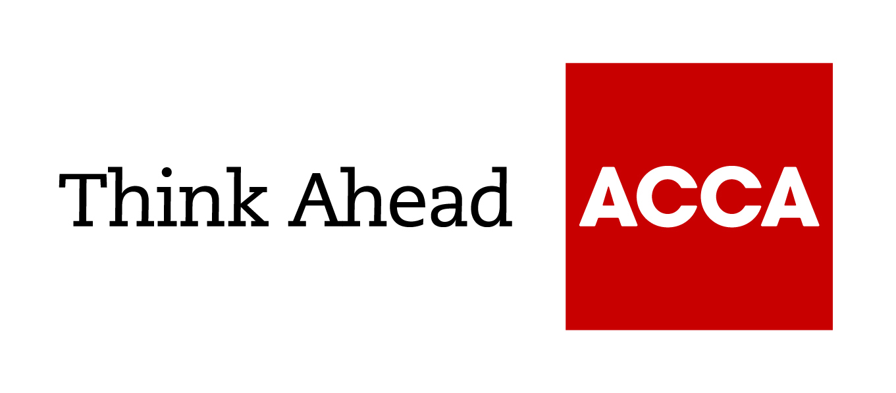
Guide from
[insert your name here]

Tel: [insert telephone number here] Email: [insert email address here] [Insert web address here]

[Insert a line about your business here]

Annual Investment Allowance

Annual Investment Allowance (AIA) is effectively a 100% first-year allowance for business expenditure on qualifying plant or machinery.

The general rule is that qualifying expenditure is
- expenditure on the provision of plant or machinery wholly or partly for the purposes of a qualifying activity that the person incurring the expenditure carries on, and
- as a result of incurring the expenditure the person incurring the expenditure owns the plant or machinery.
Plant or machinery covers many assets that a qualifying person may buy for the purposes of his business. Assets not covered by the AIA are land, buildings and cars. Typical examples of plant or machinery include:
- computers
- all kinds of office furniture and equipment
- vans, lorries, trucks, cranes and diggers
- ‘integral features’ of a building or structure
- other building fixtures, such as shop fittings, kitchen and bathroom fittings
- all kinds of business machines
- tractors, combine harvesters and other agricultural machinery
- gaming machines, amusement park rides
- computer aided machinery, including robotic machines
- wind turbines and fibre optic cabling.

‘Qualifying person’ means: an individual, a company and a partnership of which all the members are individuals, carrying on a qualifying activity. A qualifying activity includes trades, professions, vocations, ordinary property businesses and employments or offices.
Trusts and partnership of which a company is a member do not fall within the definition of a qualifying person.

Where businesses spend more than the annual limit, any additional expenditure is dealt with in the normal capital allowances regime, entering either the main rate or special rate pool, where it will attract writing-down allowances at the 18% or 8% rate respectively.

AIA is not available:
- on assets not used immediately in the trade
- in the chargeable period in which the qualifying activity is permanently discontinued
- on a transaction with a connected person.

The maximum AIA available is as follows:

Date of expenditure | Maximum AIA
01/04/2008 – 31/03/2010 for companies  06/04/2008 – 05/04/2010 for unincorporated business | £50,000
01/04/2010 – 31/03/2012 for companies  06/04/2010 – 05/04/2012 for unincorporated business | £100,000
01/04/2012 – 31/12/2012 for companies  06/04/2012 – 31/12/2012 for unincorporated business | £25,000
01/01/2013 – 31/03/2014for companies  01/01/2013 – 05/04/2014for unincorporated business | £250,000
01/04/2014 – 31/12/2015 for companies  06/04/2014 – 31/12/2015 for unincorporated business | £500,000
01/01/2016 onwards for all entities | £200,000

Transitional rules
Complicated transitional rules apply where an accounting period straddles the date on which an increase or decrease in the maximum AIA rate occurs. This is best illustrated by the following example:

Example 1:
This example looks at an accounting period where there is an increase in the maximum AIA limit.
Moeen Ltd has a year end of 30 September 2014. During that period, it incurs the following expenditure on qualifying plant and machinery:
- 01/10/2013 – 31/03/2014 £200,000
- 01/04/2014 – 30/09/2014 £150,000
Total £350,000
How much of the above expenditure will be eligible for AIA?
Methodology:
It is necessary to time-apportion and look at the two component periods separately:
- for the period from 01/10/2013 – 31/03/2014, the limit will be
£250,000 x 6/12 = £125,000
- for the period from 01/04/2014 – 30/09/2014, the limit will be
£500,000 x 6/12 = £250,000.
The aggregate maximum for the period is therefore
£125,000 + £250,000 = £375,000

Next, we need to consider how these interact:
- The legislation tells us that, for the period before the change, when considering the expenditure eligible for relief, you take the total of the two component periods.
- For the period after the change, the maximum AIA is restricted to the maximum AIA for the second component period only.

In our example, therefore, the AIA due would be as follows:
Expenditure incurred before 01/04/2014
(Lower of £200,000 and £375,000) £200,000
Expenditure incurred after 31/03/2014
(Lowest of ((£375,000 – £200,000) AND £150,000 AND £250,000) £150,000
Total AIA £350,000

Example 2:
This example looks at an accounting period where there is an increase in the maximum AIA limit and assumes that the maximum AIA limit will reduce back to £200,000 from 01/01/2016.
Root Ltd has a year end of 30 June 2016. During that period, it incurs the following expenditure on qualifying plant and machinery:
- 01/07/2015 – 31/12/2015 £240,000
- 01/01/2016 – 30/06/2016 £100,000
Total £340,000
How much of the above expenditure will be eligible for AIA?

Methodology
Again, it is necessary to time-apportion and look at the two component periods separately:
- For the period from 01/07/2015 – 31/12/2015, the limit will be
£500,000 x 6/12 = £250,000
- For the period from 01/01/2016 – 30/06/2016, the limit will be
£200,000 x 6/12 = £100,000.
The aggregate maximum for the period is therefore
£100,000 + £250,000 = £350,000.
Next, we need to consider how these interact:
- The legislation tells us that, for the period before the change, when considering the expenditure eligible for relief, you take the total of the two component periods.
- For the period after the change, the maximum AIA is restricted to the maximum AIA for the second component period only.

In our example, therefore, the AIA due would be as follows:

Expenditure incurred before 01/01/2016
(Lower of £240,000 and £350,000) £240,000
Expenditure incurred after 31/12/2015
(Lowest of ((£350,000 - £240,000) AND £100,000 AND £100,000) £100,000
Total AIA £340,000

An important point to note is that the AIA may be allocated in the most beneficial way.

Example:
Brendan Ltd incurs the following expenditure on plant and machinery during the year ended 30 September 2012:
- 1 January 2012 New lathe (general pool item) £100,000
- 1 February 2012 New lift shaft (reduced rate pool item) £100,000
Brendan Ltd should use its entitlement to AIA against the assets that attract the lower rate of writing down allowance (WDA) first and claim the higher WDA on the additions to the general pool.
Assuming there are no brought forward capital allowance pools brought forward, Brendan Ltd’s maximum capital allowances entitlement for the year ended 30 September 2012 would be as follows:

 |  |  |  | 10% | 20% | Rate of | Allowances
 |  |  | AIA | Pool | Pool | C/A | Due
Lift shaft
Max AIA:
6/12 x £100,000 |  | 50,000
+
6/12 x £25,000 |  | 12,500
Total Maximum AIA |  | 62,500 | 62,500 |  |  | 100% | 62,500
Balance (£100,000 - £62,500) |  |  |  |  | 37,500 | 20% | 7,500
New lathe |  |  |  | 100,000 |  | 10% | 10,000
Total capital allowances |  |  |  |  |  |  | £86,250

The following provisions apply to restrict the amount of annual investment allowance:
- Groups of companies are entitled to only one AIA between them, but the companies can allocate the allowances between them as they think fit.
- Companies or groups of companies that are controlled by the same person and are related to one another are entitled to only one AIA.
- If one person carries on two or more qualifying activities, he is entitled to only one AIA for the chargeable periods for those activities that end in the tax year.
- If more than one person carries on the qualifying activities, they are between them entitled to only one AIA for chargeable periods for those activities that end in the tax year.

June 2018

ACCA LEGAL NOTICE
This is a basic guide prepared by ACCA's Technical Advisory Service for members. It should not be used as a definitive guide, since individual circumstances may vary. Specific advice should be obtained, where necessary.

