VAT- the change in the standard rate

A SIMPLE GUIDE TO THE CHANGE IN THE STANDARD RATE OF VAT TO 20%
This is a basic guide prepared and issued by HM Revenue and Customs (HMRC) to assist in understanding the changes. It is distributed by ACCA for members to use as they wish. It is an introduction only and should not be used as a definitive guide, since individual circumstances may vary. Specific advice should be obtained, where necessary.

Emergency Budget on 22 June 2010
In the Emergency Budget on 22 June 2010 the Chancellor announced that the standard rate of VAT will be increased to 20% on 4 January 2011.
What do I have to do?
For any sales of standard-rated goods or services that take place on or after 4 January 2011 you should charge VAT at the new rate of 20%. This means that cash businesses which currently calculate their VAT using the VAT fraction of 7/47 should, from January 2011, use the new VAT fraction of 1/6.

Which of my sales are affected?
Only standard-rated sales are affected. There are no changes to sales that are zero-rated or reduced-rated for VAT. Similarly, there are no changes to the VAT exemptions. Any sales you make at these rates are unaffected.
For your standard-rated sales, it depends how you normally account for VAT:
- If you are a retail business making mainly cash sales to customers not registered for VAT (e.g. a shop, restaurant, takeaway or hairdresser)
You should use the new rate for all takings that you receive on or after 4 January 2011.
Except for where your customer pays for something they took away (or you delivered) before 4 January 2011 (e.g. where customers have an account with you). In this case, your sale took place before 4 January 2011 and you must use the old rate of 17.5%.
- If you are a business that sells mainly to other VAT-registered businesses and have to issue VAT invoices.
You should use the new rate of 20% for all VAT invoices that you issue on or after 4 January 2011,
Except for where you provided goods or services more than 14 days before you issue the VAT invoice. For example, if you issue a VAT invoice on 4 January 2011 for goods or services provided before 19 December 2010, or you were paid before 4 January 2011. In these cases, your sale took place before 4 January 2011 and you must use the old rate of 17.5%.
What about continuous supplies of services e.g. work in progress?
For continuous supplies of services, such as ongoing construction work, you should account for the VAT due whenever you issue a VAT invoice or receive payment, whichever is the earlier. In these cases, invoices issued or payments received on or after 4 January 2011 will be subject to 20% VAT.

Are there any special rules for sales spanning the change of rate?
Yes. If you have received a payment or issued an invoice before 4 January 2011 for goods that will be provided (or services delivered) after 4 January 2011, you have a choice. You can choose to account for VAT at the new rate of 20% on the amounts already received or invoiced. You don’t need to tell HMRC if you do this. In these circumstances, any payments received or invoices issued after 4 January 2011 will always be subject to the new rate of 20%. But you do need to issue a credit note to your customer if you have already issued a VAT invoice showing the old rate of VAT.

What VAT can I claim back on my business purchases?
The general rule is that you claim back the VAT you have been charged by your supplier in the normal way. You will still be receiving invoices after 4 January 2011 showing 17.5% VAT – that will be expected – as these will be invoices relating to purchases you have made before the rate change. In these cases you can claim back the 17.5% VAT.

What do I do about my VAT return?
You will continue to receive or file VAT returns in the normal way i.e. either monthly, quarterly or annually. The deadlines for submitting your VAT returns and making payments are unchanged. For return periods that cover both before and after 4 January 2011, you will need to add together the VAT on sales charged at 17.5% and the VAT on sales charged at 20% to work out the total VAT on sales to be included in Box 1 of your VAT return.

What if I use a computer, VAT software or an electronic till?
If you have a software package that automatically calculates the VAT, you will need to ensure that the VAT rate is changed from 17.5% to 20% from 4 January 2011. This may be something that you can do yourself – otherwise you will need to contact your software provider or supplier for assistance. Most software packages should have the in-built capability to deal with changes in the rate.

You may be able to adjust your electronic till yourself but if not you will need to contact your till supplier for assistance. If your till has not been amended to calculate 20% (rather than 17.5%) by 4 January 2011 you will need to calculate the VAT manually. You simply take the standard-rated gross takings calculated by your till and multiply that sum by the new VAT fraction of 1/6 - this will give you the amount of 20% VAT.

What if I make an error associated with this change?
If you discover that you have made an error you can correct it in the normal way by making a voluntary disclosure or correcting it on your next return (subject to the normal limit).

HMRC recognises that this is a change that businesses will have to implement. Therefore we will adopt a “light touch” in relation to errors or mistakes made in the first VAT return after the change. We will take into account the difficulties a business has faced in adjusting to the change.

What about the special VAT schemes for small businesses?
The Cash Accounting and Annual Accounting Schemes remain unchanged. However, the Flat Rate Scheme percentages are changing to reflect the new rate of VAT. If you are on the Flat Rate Scheme please refer to the additional information on the HMRC website (see below). You will need to use the new rates for your sector from 4 January 2011.

This is a guide for ACCA members to assist in understanding the VAT changes and to provided assistance when dealing with clients or helping colleagues. This document has no regulatory status and provides and overview of the changes.

Reproduced by kind permission of HMRC as part of its support to its customers. Further guidance is available at www.hmrc.gov.uk

COURTESY OF
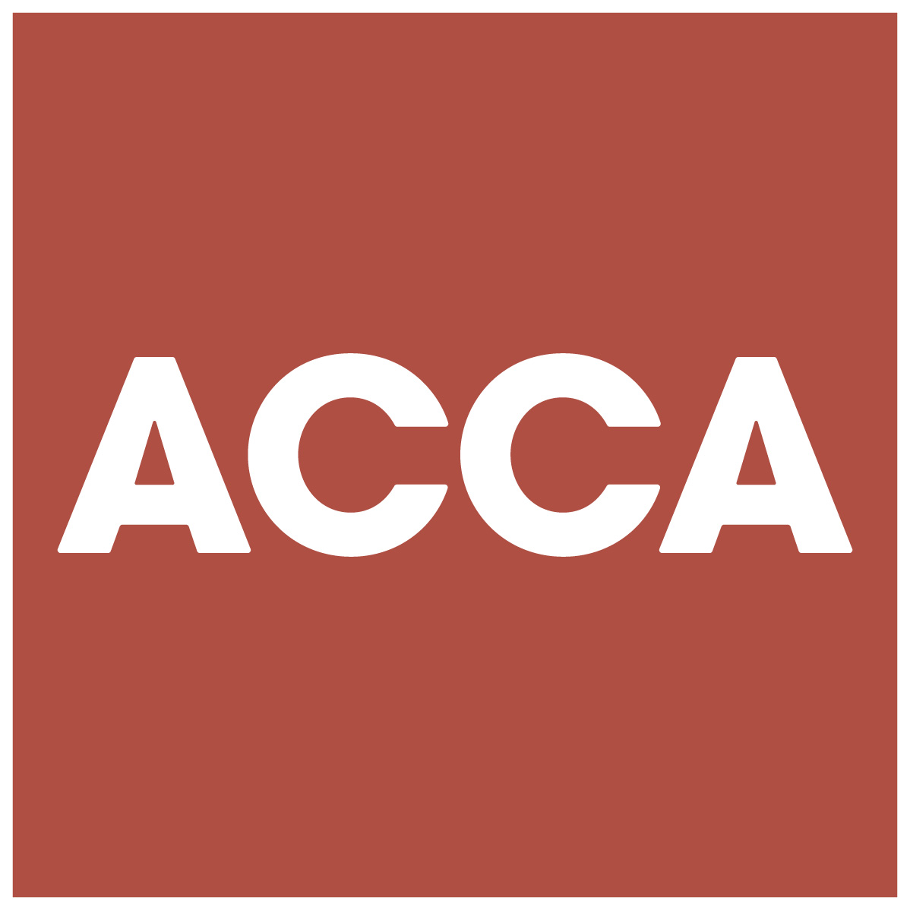

ACCA LEGAL NOTICE

This Guide is an example only. It may not address all of the issues for each specific client. You should undertake additional research into any client matters not dealt with in the examples and amend your advice accordingly.

While every care has been taken in the preparation of this Guide, neither the writer nor ACCA accept any responsibility for any loss occasioned by reliance on the Guide.

